Development of a “Restaurant Management System for EmpowerBD"

Jannatun Ferdous Jerin
ID# 21303178

A Practicum in the Partial Fulfillment of the Requirements
for the Award of Bachelor of Computer Science and Engineering (BCSE)

Department of Computer Science and Engineering
College of Engineering and Technology
IUBAT—International University of Business Agriculture and Technology
Summer 2026

Development of a “Restaurant Management System"
Jannatun Ferdous Jerin

A Practicum in the Partial Fulfillment of the Requirements for the Award of Bachelor of Computer Science and Engineering (BCSE)
The practicum has been examined and approved,

_____________________________
Prof. Dr. Utpal Kanti Das
Chairman

_____________________________
Shahinur Alam
Co-supervisor, Coordinator and Assistant Professor

_____________________________
M. M Rakibul Hasan
Supervisor and Assistant Professor

Department of Computer Science and Engineering
College of Engineering and Technology
IUBAT—International University of Business Agriculture and Technology
Summer 2026

Letter of Transmittal

Organization’s Certificate

Student’s Declaration

I, Jannatun Ferdous Jerin (ID: 21303178), a student of the Bachelor of Computer Science and Engineering (BCSE) program under the College of Engineering and Technology (CEAT) at the International University of Business Agriculture and Technology (IUBAT), hereby declare that this report on the topic “Development of a Restaurant Management System for EmpowerBD” has been prepared to fulfill the requirements of the Internship Course CSC 490, which is a partial requirement for the Bachelor of Computer Science and Engineering degree.
I confirm that I have developed this report and the associated project independently. All modules and processes have been thoroughly tested and meet the requirements of the project client. This report has not been prepared for any other purpose, reward, or presentation.

_____________
Jannatun Ferdous Jerin
21303178

Supervisor’s Certification

This is to certify that the practicum report titled “Development of Restaurant Management System for EmpowerBD” has been conducted by Jannatun Ferdous Jerin (ID: 21303178), an undergraduate student of the Bachelor of Computer Science and Engineering (BCSE) program in the Department of Computer Science and Engineering at IUBAT—International University of Business Agriculture and Technology, as part of the requirements for the practicum defense course. This report was prepared under my supervision and records the work completed for the project. To the best of my knowledge and based on the student’s declaration, no portion of this report has been previously submitted for any degree, diploma, or certification. Jannatun Ferdous Jerin is hereby authorized to submit this report, and I extend my best wishes for her continued success.

_______________________________
M. M Rakibul Hasan
Supervisor and Assistant Professor
Department of Computer Science and Engineering
IUBAT—International University of Business Agriculture and Technology

Abstract

The project titled "Development of a Restaurant Management System for EmpowerBD" is a web-based application built to support the daily work of a restaurant. It was developed with Laravel, Bootstrap, and MySQL, using XAMPP for local development. The system covers common restaurant tasks such as taking orders, managing menu items, checking inventory, recording payments, and preparing reports. The purpose of the project is to reduce the amount of manual work needed in these areas and to make the workflow easier for staff and management.

The main goal of the system is to reduce mistakes that often happen when orders, bills, and stock records are handled manually. Staff can create and track orders, cashiers can process payments, chefs can view kitchen orders, and managers can check inventory and reports from one system. This helps the restaurant keep better records and respond faster during regular service hours.

Laravel was used for the backend because it provides routing, authentication, database handling, and structured application development. Bootstrap was used to build a responsive interface, and MySQL was used to store user, menu, order, inventory, and payment data.

The completed system improves the basic restaurant workflow by connecting ordering, kitchen processing, stock tracking, payment handling, and reporting. Future work may include a mobile version, more advanced reports, and integration with other business tools.

-

Acknowledgments

In the name of ALLAH, the Most Merciful and Gracious, I present this report on the project titled “Restaurant Management System.” This work would not have been possible without the support and guidance of many people.
First, I sincerely thank our respected Chairman, Prof. Dr. Utpal Kanti Das, whose inspiration and encouragement motivated me to complete this project with dedication.
I am also deeply grateful to my Coordinators, Md. Rashedul Islam, Associate Professor, and Shahinur Alam, Assistant Professor, Department of Computer Science and Engineering, IUBAT. Their guidance and feedback were essential in shaping this report.
Special thanks go to my Supervisor, M. M Rakibul Hasan, Assistant Professor, Department of Computer Science and Engineering, IUBAT, for his valuable suggestions and continuous support. His mentorship was a great source of learning and motivation.
I also appreciate my friends and classmates for their helpful feedback and encouragement throughout different stages of the project.
Above all, I am forever thankful to my parents for their unconditional love, prayers, and constant support. Their blessings have been the true driving force behind my journey.

Chapter 1. Introduction

Restaurants need fast service, accurate billing, and clear communication between staff members. When these activities are handled with paper notes or separate tools, mistakes can happen easily. Orders may be delayed, kitchen staff may receive incomplete information, and inventory records may not match actual stock. For this reason, the Restaurant Management System for EmpowerBD was developed as a single web application for managing the main restaurant operations.

1.1 Background of the Study
A restaurant has many activities running at the same time. Staff members manage tables, take orders, send items to the kitchen, collect payments, and check stock. In a manual process, these tasks are not always connected. For example, a cashier's note does not update the kitchen queue or the inventory record by itself. This project connects those steps so that order information can move from the customer side to the kitchen, payment, and reporting modules more clearly.
The Restaurant Management System for EmpowerBD was built to handle these needs. It supports order taking, menu management, inventory tracking, payment processing, and report generation. By replacing repeated manual work with system-based records, the restaurant can reduce errors and serve customers in a more organized way [4].

1.2 Methodology
This project's methodology integrated research knowledge with practical implementation. An iterative approach was used throughout development, where each feature, including order management, payment processing, inventory control, and user roles, was implemented, tested, and refined.
Both primary and secondary sources of information were used during the research phase.

1.2.1 Primary Sources.
The following steps were used for collecting primary-source information:
- Simulated Operations: Running mock restaurant environments to test order flows and identify UI friction.
- Expert Consultations: Regular discussions with academic supervisors and senior developers to refine system architecture.
- Workflow Observation: Analyzing how staff and cashiers naturally interact with point-of-sale interfaces.
- User Feedback: Collecting informal feedback from restaurant staff and management on system usability.
- Trial Runs: Running simulated restaurant operations (order taking, payment processing, and inventory tracking) to identify gaps and fix errors [4].

1.2.2 Secondary Sources.
The secondary sources used are listed below:
- Technical Documentation: References to official guides for Laravel, Bootstrap, and MySQL.
- Academic Materials: Lecture notes and course handouts from the Department of Computer Science and Engineering.
- Online Resources: Articles, tutorials, and forums related to POS systems, database optimization, and inventory management tools.
- Case Studies: Previous project reports and research papers on similar restaurant management systems.
Together, these sources provided both practical insights and theoretical understanding for building the project.

1.3 Objectives
The main aim of the project is to build a practical restaurant management system that supports daily operations and reduces manual errors. The objectives are given below:

1.3.1 Broad Objective.
To design and implement the Development of a Restaurant Management System for EmpowerBD, which supports order management, inventory tracking, billing, user roles, and reporting in one application.

1.3.2 Specific Objectives.
- To implement user and role management for secure access control.
- To automate the ordering process, including menu management and payment processing.
- To enable real-time inventory tracking and automatic low-stock alerts.
- To provide tools for generating daily, weekly, and monthly sales reports.
- To ensure secure payment processing and safe handling of customer transaction data.
- To collect customer feedback in a simple way so that service quality can be reviewed.
- To reduce manual effort, speed up billing, and improve decision-making for both staff and restaurant management.

1.4 Process Model
The development followed an Iterative Process Model. Instead of building the entire system at once, the project was divided into modules (for example, order management, payment processing, and inventory management). Each module was:
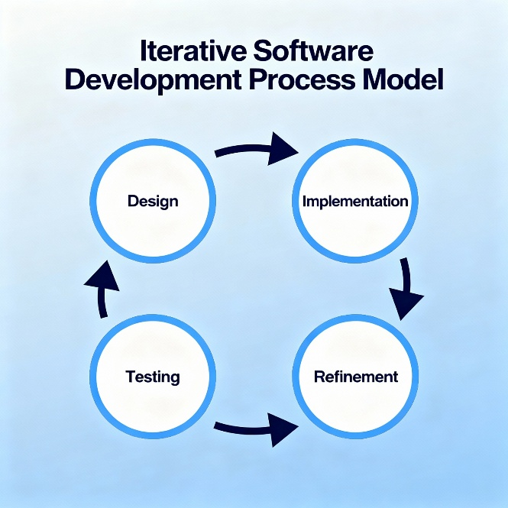
Figure 1.4: Iterative Process Model
- Designed based on requirements.
- Implemented using Bootstrap for the frontend, Laravel for backend services, and MySQL for database management.
- Tested through trial runs, including real-world order simulations.
- Improved based on feedback from restaurant staff and managers.
This approach provided flexibility. If an issue was found during testing, only that module needed revision without affecting the rest of the system. The iterative model was selected because it supports gradual improvement and frequent testing, which is essential for order systems where accuracy is critical.

1.5 Feasibility Study
Before starting development, a feasibility study was conducted to ensure the project was technically possible, economically viable, and operationally practical. The proposed system is feasible in all three dimensions, as discussed below:

1.5.1 Technical Feasibility.
The technologies used, Laravel, Bootstrap, and MySQL, are stable, widely adopted, and well supported. They provide:
- Strong database handling for restaurant order records.
- Customizable workflows suitable for order management and inventory tracking.
- Secure and real-time payment processing capabilities.
- The hardware and software requirements were minimal and easily available, confirming that the project was technically feasible.

1.5.2 Economic Feasibility.
The project used cost-effective tools. Bootstrap and Laravel are open-source frameworks, and MySQL is a widely used database system that minimizes licensing costs. By automating manual tasks, the system reduces operational costs in the long term, making it economically sustainable.

1.5.3 Operational Feasibility.

1.6 Structure of the Report
This report is organized into chapters covering the organization context, requirements, modelling, project management, testing, ethical considerations, and conclusion.
The system was designed to be easy to use. Staff can work with common modules such as login, orders, payments, reports, menu, and inventory without needing long training. Customers also benefit from clearer order handling and faster billing. For these reasons, the system is suitable for practical restaurant use.

Chapter 2. Organizational Overview

EmpowerBD is a software and IT solutions company providing custom digital services and operational software for business clients.

Figure 2.1: EmpowerBD Company Structure

2.1 Organization Vision
Vision: “We code better life.”
This concise, aspirational statement reflects EmpowerBD's commitment to enhancing everyday experiences through smart, efficient, and life-enriching digital solutions.

2.2 Organization Mission
To provide practical, quality-driven digital solutions through collaborative technical teams.

2.3 Organization Services
EmpowerBD provides software and IT-related services for different types of business clients. The main services include:
- Web and business application development
- Restaurant management and inventory solutions
- Digital platform support services

2.4 Organizational Structure

2.5 My Position in this Organization
I worked as a practicum trainee and contributed to requirement analysis, module implementation support, integration validation, and testing documentation.

2.6 Address of the Organization
EmpowerBD, House 60/F, Road 13, Sector 13, Uttara, Dhaka 1230, Bangladesh.

Chapter 3. Requirement Engineering

Requirement engineering is an important part of this project because it defines what the system should do before development starts. For the Restaurant Management System, this step helped identify the main workflows, such as order management, payment processing, inventory tracking, user roles, and reporting. Clear requirements made the development process easier to plan and test.
This chapter details the requirement elicitation, analysis, specification, and use-case modeling of the Restaurant Management System. Each section has been expanded to provide practical insights and real-world scenarios that illustrate the system's functionality.

3.1 Requirement Elicitation "Development of a Restaurant Management System for EmpowerBD "

3.1.1 Stakeholder Identification
Primary stakeholders were identified as follows:
Primary Stakeholders:
- System Administrators/Owners: Require macro-level control, financial summaries, and system configuration access.
- Restaurant Managers: Oversee daily operations, manage orders, and monitor inventory.
- Waitstaff: Input customer orders, process payments, and communicate with the kitchen.
- Customers: End users who interact with the system via the point-of-sale interface to place orders and make payments.
- Kitchen Staff: Depend on clear, immediate visual cues regarding incoming, pending, and completed food orders.

3.1.2 Techniques Used for Elicitation
A combination of elicitation techniques was applied to ensure completeness:
- Interviews: Conducted with restaurant staff and managers to uncover operational workflows. One manager emphasized, "We need a fast and reliable order management system."
- Observation: Analysts observed the order-taking process, identifying tasks like manual billing and inventory tracking that could be automated.
- Workshops: Collaborative workshops with staff helped define roles, order flows, and reporting needs.
- Document Analysis: Reviewed industry standards for POS systems and compliance requirements to ensure the system meets legal and operational guidelines.
- Prototyping: Early UI mock-ups were shared with staff to validate system usability and design.

Using more than one requirement collection method helped make the requirements more practical and easier to verify.
3.1.3 Key Findings
The elicitation process revealed critical requirements:
- Secure login and role-based access for users.
- Easy menu setup and item management.
- Real-time order tracking and payment processing.
- Reporting tools for daily sales, inventory levels, and customer orders.
- Integration with payment gateways for secure transaction handling.
- Ability to generate end-of-day reports, including sales summaries and inventory updates.
- Automatic backup and recovery of transaction data.

3.2 Requirement Analysis of "Development of a Restaurant Management System for EmpowerBD"
Requirement analysis refines elicited data to identify conflicts, assess feasibility, and prioritize needs. For the Restaurant Management System, analysis was particularly important due to workflow complexity and the need for real-time data processing.

3.2.1 Completeness and Consistency
Completeness ensures all critical features are included, while consistency ensures no contradictions exist [10].
- Completeness: Analysts cross-checked elicited requirements against existing restaurant workflows to ensure that all critical features like order processing, inventory management, and reporting were included.
- Consistency: Conflicts arose, such as waitstaff requesting more detailed customer order information, while managers insisted on limiting access. This was resolved through role-based access control, allowing waitstaff to only see customer orders and not sensitive payment data.

3.2.2 Feasibility Study
Feasibility analysis assessed multiple dimensions:
- Technical Feasibility: The system will be developed as a web-based application using Bootstrap for the interface, Laravel for backend services, and MySQL for database management.
- Operational Feasibility: Staff are familiar with basic digital tools, and minimal training will ensure smooth adoption of the POS system.
- Economic Feasibility: The cost of implementation will be justified by the time saved through automation, reduced human error, and improved reporting accuracy.
- Schedule Feasibility: A phased implementation within three months is achievable, with pilot runs and feedback cycles to ensure system quality.

Requirement specifications formalize user and system needs, providing developers with a concrete reference.

3.3 Requirement Specifications

3.3.1 User Requirements
Primary Actor: Administrator
- The Administrator must securely authenticate into the system using valid login credentials.
- The Admin is tasked with overseeing and controlling all aspects of the restaurant's digital operations, encompassing order fulfillment, financial transactions, and stock control.
- Full privileges are granted to the Admin to set up and modify the digital menu, adjusting prices, categories, and general restaurant configurations.
- The user must be able to manage the full order process, including order creation, status update, and final payment.
- The Admin is authorized to extract detailed analytical reports spanning daily, weekly, or monthly timeframes.
- The user carries the responsibility of cross-checking and validating the integrity of all operational data entered into the platform.
- Routine operational triggers, specifically the initialization (Day-Start) and closure (Day-End) of business days, are exclusively executed by the Admin.
- The user is responsible for monitoring real-time stock levels, adjusting inventory parameters, and maintaining supplier databases.
- The Admin maintains overarching visibility over all system interactions to guarantee operational precision.
- Absolute administrative rights are assigned to this user, allowing unrestricted creation, modification, or deletion of system records and settings.
- The user manages all customer-related data, including historical order logs and feedback records.
- The Admin initiates system backups and governs data restoration procedures.

3.3.2 System Requirements
Authentication Workflow:
- The system must provide a secure login interface where the administrator inputs their assigned username and password before submitting the request.
- Upon successful verification of the credentials, the system automatically redirects the user to the central management dashboard, granting full operational access.
- In the event of mismatched or incorrect credentials, the system must deny access and display a clear "Invalid username or password" alert.

3.3.3 Functional Requirements
These specifications define the core behaviors and capabilities of the Restaurant Management System:
- The software shall serve as a unified platform empowering the administrator to orchestrate and oversee all restaurant-related activities.
- The system shall feature a secure repository for storing customer profiles, capturing details such as contact information, historical orders, and payment records.
- The system must include a menu database that can be updated when prices, categories, ingredients, or availability change.
- The application must facilitate end-to-end order management, capturing the workflow from initial order placement through status updates, financial settlement, and receipt printing.
- The system shall execute dynamic inventory tracking, featuring automated low-stock notifications and supplier management tools, strictly accessible by the administrative role.
- The software must provide reports that show useful information such as sales, stock use, and restaurant activity.

3.3.4 Non-Functional Requirements
Performance Metrics:
- Latency: All standard operations and interface interactions must execute and respond within a 5-second window.
- Throughput: The system should be able to handle regular restaurant transaction volume without slow response during busy hours.
- Concurrency: The platform must smoothly support multiple administrators operating simultaneously without session conflicts.
- Database Efficiency: Complex data queries, especially those driving analytics and reporting, must resolve and render in under 3 seconds.
Security Standards:
- Data Security: Sensitive information, especially passwords and payment-related data, must be protected using secure storage and encryption practices.
- Access Control: The system must strictly enforce Role-Based Access Control (RBAC), ensuring only verified administrative identities can reach sensitive modules.
- System Logging: An immutable audit trail must be maintained, meticulously recording all user activities, database modifications, and transactional events for future security audits.
- Data Preservation: Automated, encrypted data backups must be generated securely during the day-end closure sequence.
System Reliability:
- High Availability: The application infrastructure must guarantee 99.9% uptime, incorporating failover protocols to prevent service interruptions during peak dining hours.
- Exception Handling: The software must gracefully catch and manage unexpected errors, presenting users with understandable alerts and clear paths for recovery.
- Information Integrity: The system must guarantee that order placements, inventory deductions, and payment records are processed synchronously and accurately, preventing any data corruption.
- Disaster Recovery: Alongside routine backups, the system must support rapid data restoration frameworks to recover quickly from any theoretical hardware or server failures.
Usability and UX:
- Interface Design: The visual interface must be highly intuitive, tailored specifically to the fast-paced nature of restaurant operations.
- Information Architecture: Navigation must remain straightforward (e.g., dedicated tabs for Orders, Payments, Inventory, Reports) to drastically reduce the learning curve for new staff.
- Dashboard Accessibility: Core management tools must be centrally located on the dashboard for immediate access upon login.
- Mistake Prevention: The UI must incorporate safeguard prompts (e.g., confirmation dialogs) to prevent users from executing accidental or destructive actions.
Scalability Potential:
- Volume Growth: The backend architecture should be capable of accommodating a 200% surge in transaction frequency and user records without requiring an immediate infrastructure overhaul.
- Storage Growth: The database should allow new menu items, customers, orders, and historical records to be added over time.
- Modular Architecture: The codebase must be structured modularly, allowing developers to easily append new features in future iterations.
Software Maintainability:
- Codebase Quality: The source code must adhere to best practices using Laravel, Bootstrap, and MySQL, ensuring maintainability and clarity for future development teams.
- Maintenance: Updates and bug fixes should be possible without disturbing normal restaurant work as much as possible.
- Health Monitoring: The application should include built-in diagnostic tools to observe system health and flag potential backend issues preemptively.
Platform Portability:
- Device Agnosticism: Being a web-based solution, the system must be fully accessible and responsive across desktops, laptops, tablets, and mobile devices.
- Browser Support: The frontend must render correctly and function flawlessly across all major web browsers (Google Chrome, Mozilla Firefox, Apple Safari, Microsoft Edge).
- Platform Support: The system should run in a standard web browser on common operating systems such as Windows, macOS, and Linux.

3.4.2 Use Case Diagram
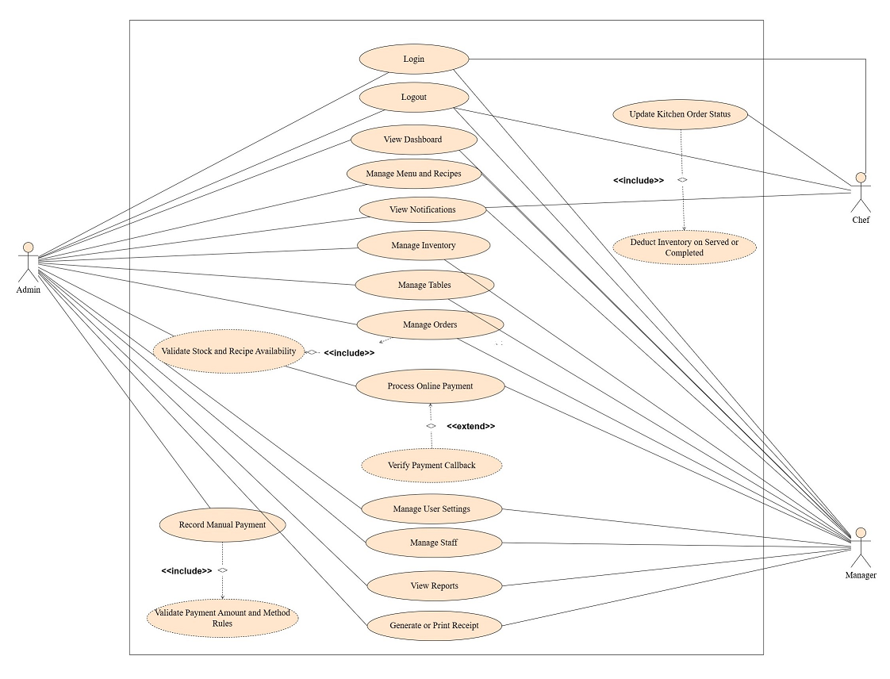

Figure 3.4.2 Use Case Diagram

Chapter 4. Analysis Modeling

4.1 Activity Diagrams

4.1.1 Admin Activity Diagram
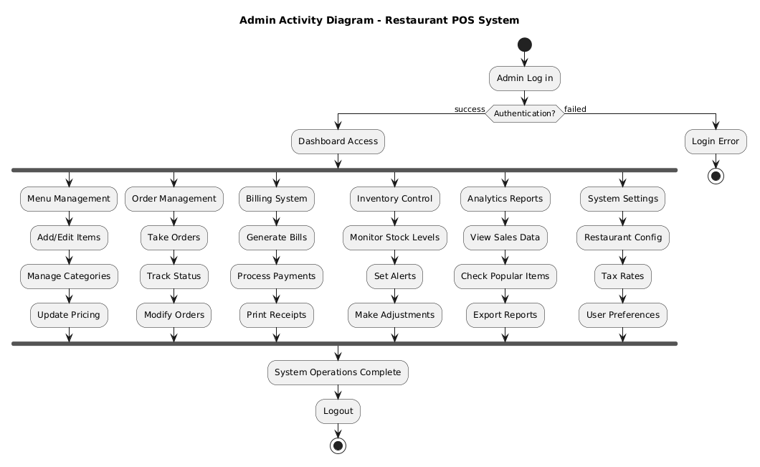
Figure 4.1.1 Admin Activity Diagram

4.2 Swim Lane Diagram

4.2.1 Swim-lane Diagram for Authentication & Login Process

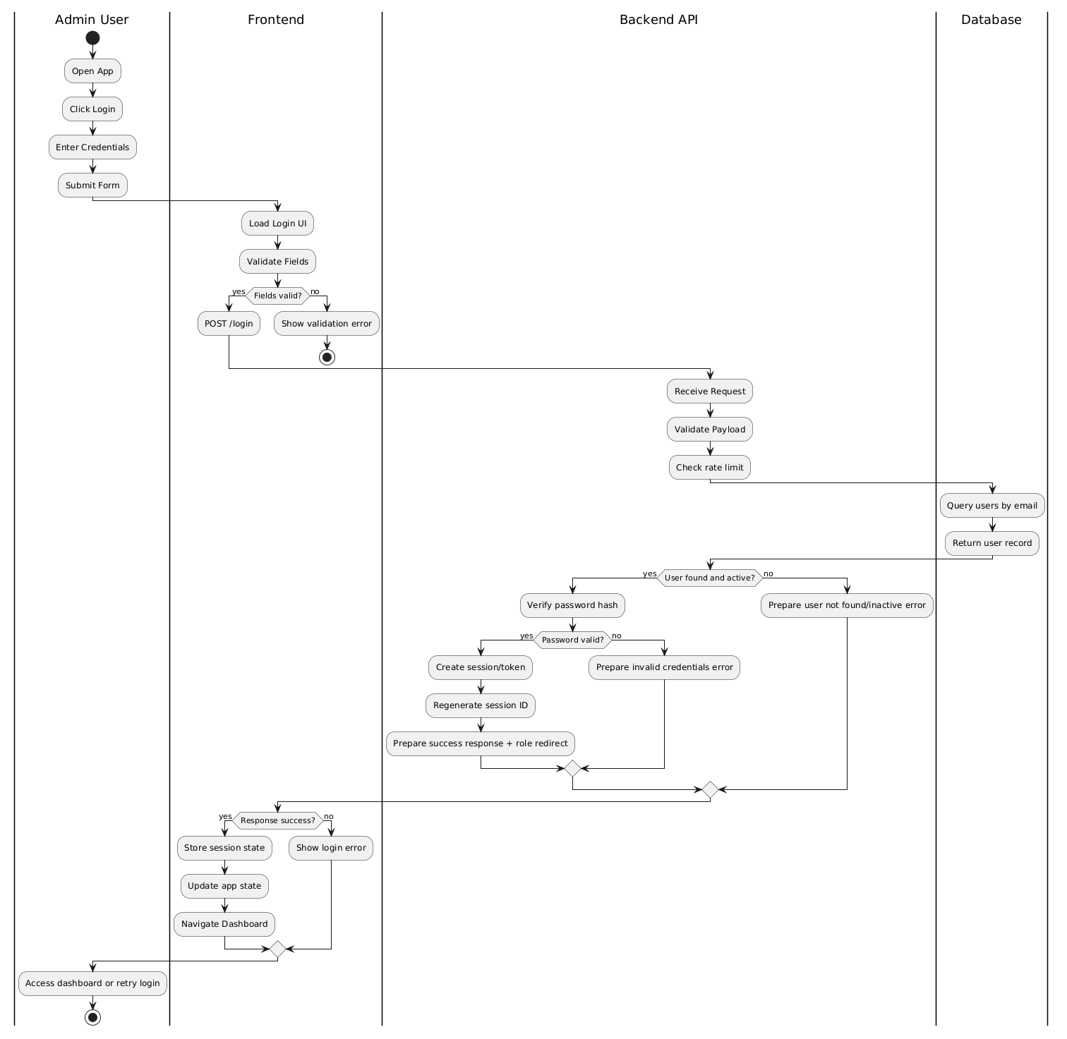

Figure 4.2.1: Authentication and Login

4.2.2 Swim-lane Diagram for Menu Management
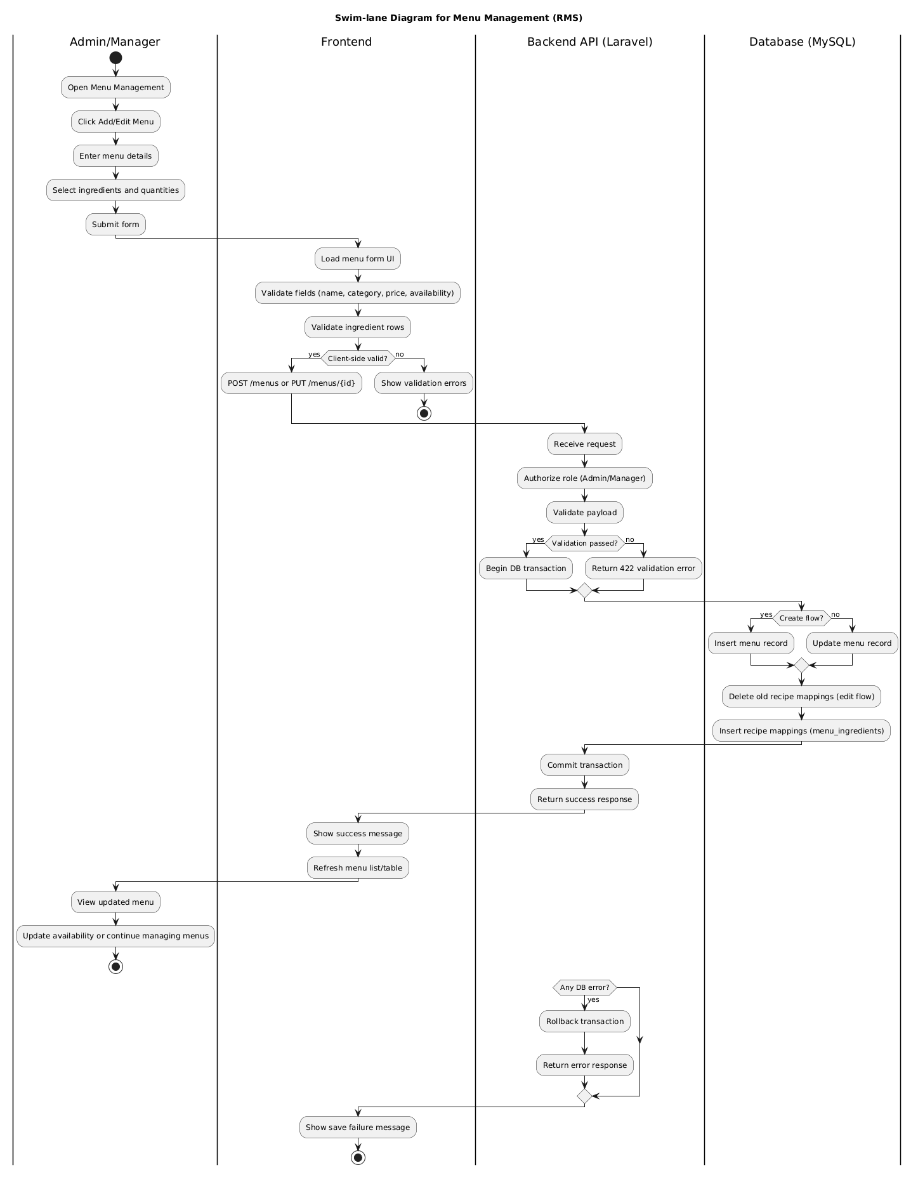
Figure 4.2.2: Menu Management

4.2.3 Swim-lane Diagram for Order Processing Workflow
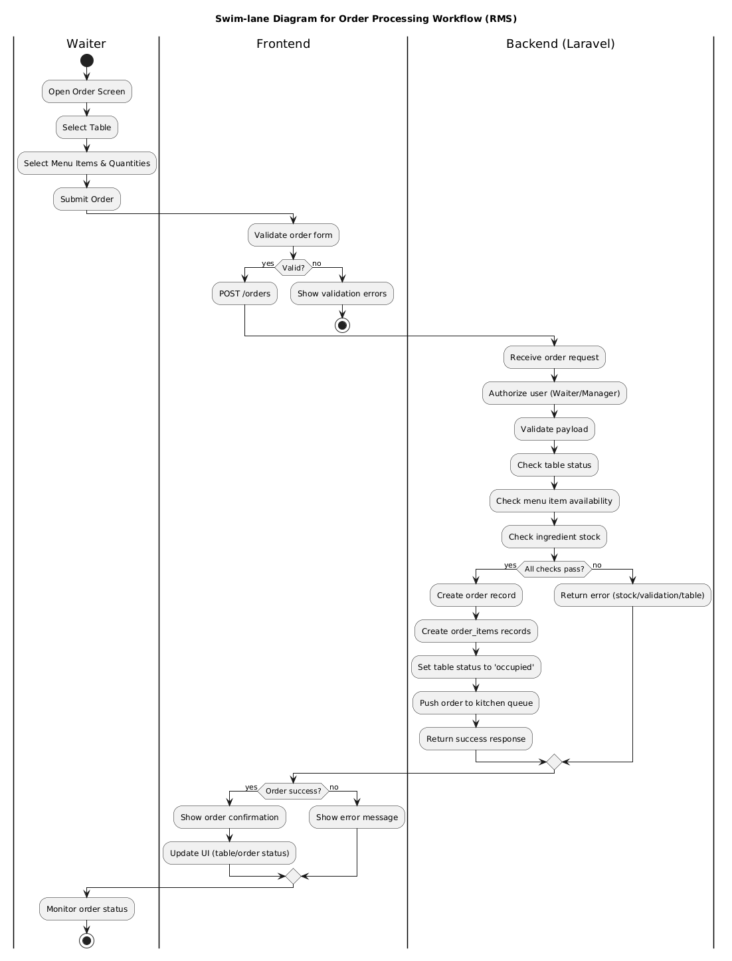
Figure 4.2.3: Order Processing Workflow

4.2.4 Swim-lane Diagram for Inventory Management
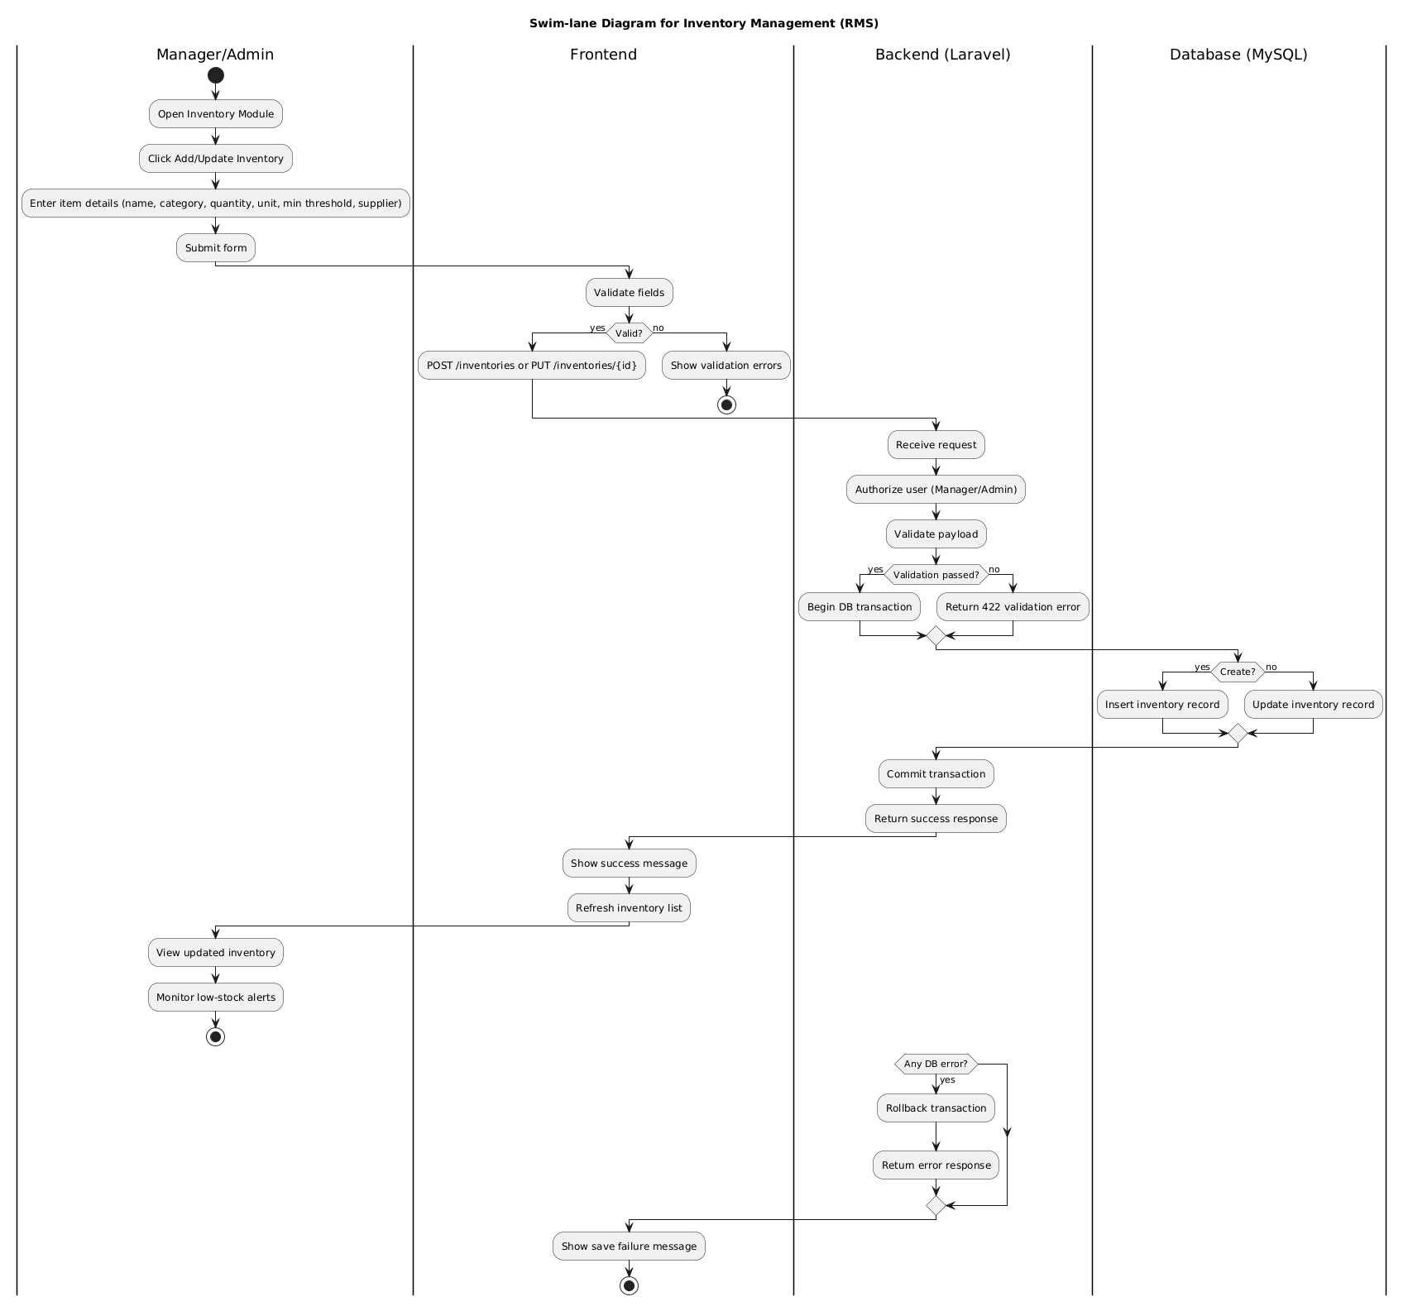
Figure 4.2.4: Inventory Management

4.2.5 Swim-lane Diagram for Report & Analytics
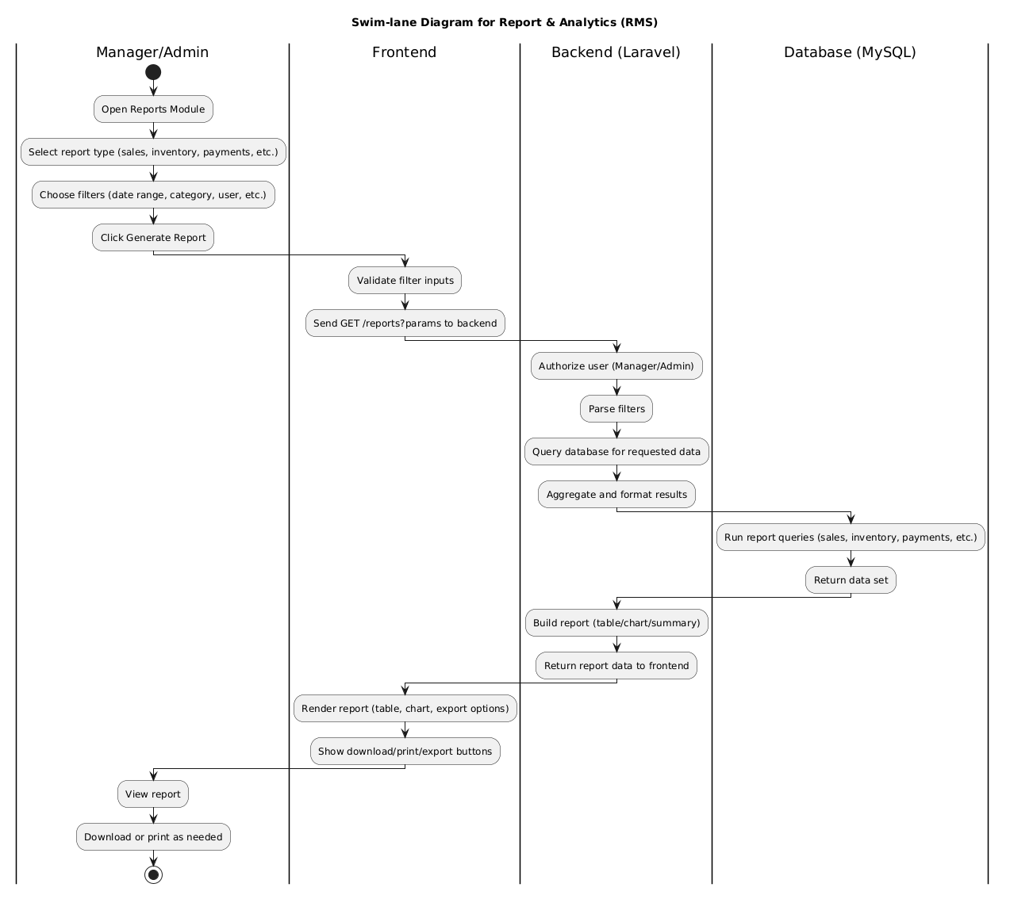
Figure 4.2.5: Report and Analytics

4.2.6 Swim-lane Diagram for Billing Module
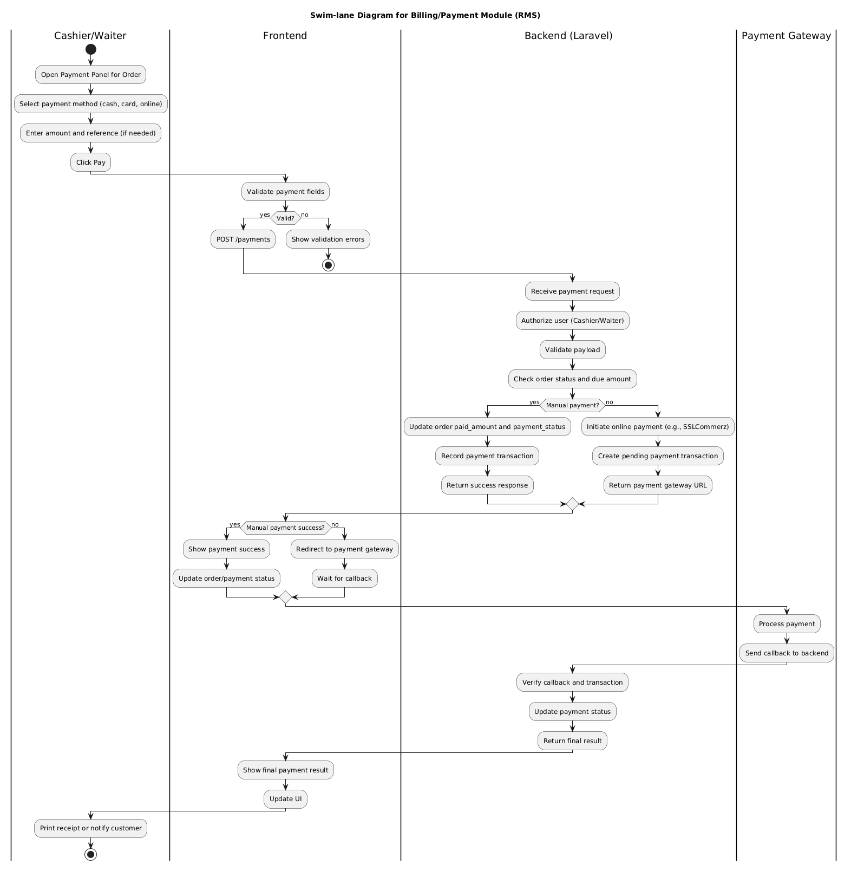
Figure 4.2.6: Billing Module

4.3 Class Diagram
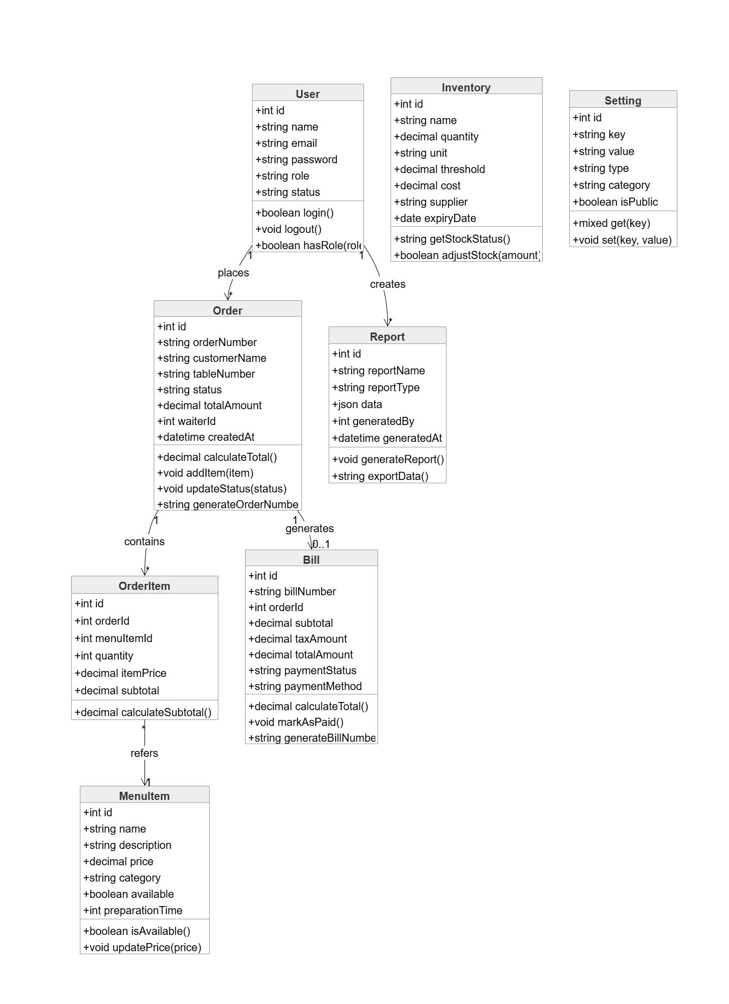

Figure 4.3 Class Diagram

Chapter 5. Project Management

Project management focused on delivery discipline and risk control.

5.1 Risk Management
Potential risks were categorized into technical, operational, and business groups.

5.1.1 Stages of Risk
Identify
Analyze
Prioritize
Plan response
Monitor and control

5.1.2 Categories of Risk
Technical
Operational
Business

5.2 The RMMM Plan
Mitigation and monitoring actions were defined for each critical risk type.

5.2.1 Project Risk Tables
The following RMMM tables list the main project risks with mitigation and monitoring actions. Each table is placed separately so that business, technical, and operational risks can be reviewed clearly.
Table 5.2.1.1: Business Risks
Risk | Probability | Impact | Mitigation | Monitoring
Scope change during development | Medium | High | Confirm features with supervisor/client before implementation | Review pending changes weekly
Delay in requirement confirmation | Medium | Medium | Use the approved requirement list as the baseline | Track unanswered requirement questions
Limited time for final polishing | Medium | Medium | Complete core modules first, then improve UI and reports | Compare progress with practicum schedule
User adoption difficulty | Low | Medium | Keep screens simple and provide clear module flow | Collect feedback during trial use

Table 5.2.1.2: Technical Risks
Risk | Probability | Impact | Mitigation | Monitoring
Database relation error | Medium | High | Use migrations, foreign keys, and test data carefully | Check migration and seed results after changes
Inventory deduction mistake | Medium | High | Deduct stock only through controlled order/kitchen flow | Test order status and stock values together
Payment gateway callback issue | Medium | High | Keep manual payment fallback and validate SSLCommerz responses | Check transaction logs after test payments
Role access misconfiguration | Low | High | Use role middleware and test each role separately | Review protected routes after route changes

Table 5.2.1.3: Operational Risks
Risk | Probability | Impact | Mitigation | Monitoring
Staff enters wrong order information | Medium | Medium | Use validation and clear order review before submission | Observe errors during sample order entry
Kitchen misses pending order | Low | High | Provide kitchen queue and status update screen | Check pending/preparing order counts
Low stock is not noticed in time | Medium | Medium | Show low-stock information in inventory module | Review low-stock list during testing
Report data mismatch | Low | Medium | Calculate report values from stored orders and payments | Compare report totals with sample orders

Table 5.2.1.4: Extended Technical Risks
Risk | Probability | Impact | Mitigation | Monitoring
Server or local environment failure | Low | High | Keep project backup and database export during development | Check backup files regularly
Browser compatibility issue | Low | Medium | Use Bootstrap and test main pages in common browsers | Open core pages after UI changes
Image/file upload problem | Low | Medium | Validate file type and store menu images in a known path | Test menu create/edit with images
Performance slowdown with more records | Medium | Medium | Use pagination and filtered queries for large lists | Review list pages with seeded data

Chapter 6. Project Planning and Scheduling
Planning and scheduling are important for completing the project within the available time. This chapter includes function point estimation, the project schedule, and the estimated development cost for the EmpowerBD Restaurant Management System.

6.1 System Requirements

6.1.1 Functional Requirements
The EmpowerBD RMS must support the following functional capabilities:
- FR1: User Authentication & Authorization - Secure login with role-based access control for Admin, Manager, Chef, Cashier, and Customer
- FR2: Table Management - Create, update, delete dining tables with capacity and status tracking
- FR3: Menu Management - CRUD operations for menu items with categories, pricing, ingredients, and availability
- FR4: Order Management - Create, modify, and track orders with real-time kitchen integration
- FR5: Inventory Management - Track ingredients, automatic deduction on order, low-stock alerts
- FR6: Payment Processing - Support cash, card, and online payments via SSLCommerz gateway
- FR7: Kitchen Workflow - Order status updates, kitchen display, preparation tracking
- FR8: Billing & Receipts - Generate itemized bills, receipts, print functionality
- FR9: Reporting - Sales reports, inventory reports, KPI dashboards, date-range filtering
- FR10: Audit Logging - Track all user actions, order modifications, payment transactions

6.1.2 Non-Functional Requirements
The system must meet the following quality attributes:
- NFR1: Performance - System must respond to user requests within 2 seconds under normal load
- NFR2: Availability - 99% uptime during business hours (9 AM - 11 PM daily)
- NFR3: Security - Password hashing (bcrypt), HTTPS encryption, SQL injection prevention
- NFR4: Scalability - Support up to 100 concurrent users without performance degradation
- NFR5: Usability - Intuitive UI requiring minimal training for restaurant staff
- NFR6: Maintainability - Modular code structure and clear documentation
- NFR7: Data Integrity - Transactional consistency for orders and payments
- NFR8: Backup & Recovery - Daily automated backups with recovery point objective (RPO) of 24 hours
- NFR9: Compliance - Support for tax calculations as per Bangladesh regulations
- NFR10: Compatibility - Works on Chrome, Firefox, Safari browsers; responsive mobile views

6.2 Function Point Estimation
Function Point Analysis (FPA) was used to estimate the size of the EmpowerBD RMS. The input, output and logical-file counts below were checked against the actual project modules, including authentication, customer ordering, staff orders, kitchen workflow, menu recipes, inventory, payments, reports and the API.

6.2.1 Identifying External Inputs (EI)
Table 6.2.1.1: External Input Function Points
External Input | Description | Complexity | FP
Staff Login | Email and password input for manager, chef, cashier and admin access | Low | 3
Customer Registration/Login | Customer account registration and login data | Low | 3
Staff Order Create/Update | Table, menu items, quantities, status and payment details | Average | 4
Customer Order Placement | Selected menu items, quantities, delivery/order notes and payment choice | Average | 4
Menu and Recipe Management | Menu name, price, category, image, availability and ingredient mapping | Average | 4
Inventory Update | Stock quantity, reorder level, unit and item details | Low | 3
Kitchen Status Update | Chef updates order status to pending, preparing or ready | Low | 3
Payment Processing | Paid amount, method, transaction reference and gateway response | Average | 4
Table Configuration | Table number, capacity and status update | Low | 3
Staff Role Management | Create or update staff user with manager, chef or cashier role | Average | 4
Total External Inputs (EI) FP = 35 points

6.2.2 Identifying External Outputs (EO)
Table 6.2.2.1: External Output Function Points
External Output | Description | Complexity | FP
Dashboard Summary | Operational cards, recent orders and role-based dashboard data | Average | 5
Kitchen Queue Display | Pending/preparing orders shown for chef processing | Average | 5
Receipt and Invoice | Printable receipt/invoice with item list, totals and payment status | Average | 5
Sales Report | Date-range revenue, order count, top items and category summary | Average | 5
Low Stock Alert | Low-stock indication based on inventory reorder level | Low | 4
Payment Confirmation | Success, fail, cancel or manual payment confirmation message | Low | 4
Public/Customer Menu View | Available menu listing grouped by category for browsing and ordering | Average | 5
API JSON Responses | Sanctum-protected menu, order and current-user responses | Low | 4
Total External Outputs (EO) FP = 37 points

6.2.3 Identifying Internal Logical Files (ILF)
Table 6.2.3.1: Internal Logical File Function Points
Internal Logical File | Record Count | Complexity | FP
Users | Admin, manager, chef, cashier and customer accounts | Low | 7
Tables | Restaurant table numbers, capacity and status | Low | 7
Menus | Menu items, categories, prices, images and availability | Low | 7
Menu Ingredients | Recipe mapping between menu items and inventory ingredients | Average | 10
Orders | Customer and staff orders, status, source and payment fields | Average | 10
Order Items | Line items, quantity, price and menu references | Average | 10
Inventories | Ingredient stock, unit and reorder-level records | Average | 10
Payment Transactions | Manual and SSLCommerz payment attempt records | Average | 10
Total Internal Logical Files (ILF) FP = 71 points

6.2.4 Function Point Calculation Summary
Table 6.2.4.1: Function Point Calculation Summary
Component | Count | Function Points
External Inputs (EI) | 10 | 35
External Outputs (EO) | 8 | 37
Internal Logical Files (ILF) | 8 | 71
Subtotal (Unadjusted FP) |  | 143

General System Characteristics (GSC) Analysis:
- Data Communications: 3 points (Integration with payment gateway)
- Distributed Processing: 1 point (Centralized server)
- Performance: 2 points (Real-time requirements for orders)
- Heavily Used Configuration: 2 points (Heavy during business hours)
- Transaction Rate: 2 points (High during peak hours)
- Online Data Entry: 3 points (Web-based input)
- End-user Efficiency: 2 points (Intuitive interface needed)
- Online Update: 2 points (Real-time inventory updates)
- Reusability: 1 point (Modular components)
Total GSC Points (TDI) = 18
Value Adjustment Factor (VAF) = 0.65 + (0.01 × 18) = 0.83
Adjusted Function Points (AFP) = 143 × 0.83 = 118.69 FP ≈ 119 FP

Effort Estimation (Laravel/PHP: 12 hours per FP):
Total Effort = 119 FP × 12 hrs/FP = 1,428 hours
Effort in Person Days (8 hrs/day) = 1,428 / 8 = 178.5 days
Effort in Man-Months (22 days/month) = 178.5 / 22 = 8.1 months
With 2 developers working full-time = 8.1 / 2 = 4.05 months
Actual practicum duration: 3 months (accelerated with focused scope)

6.3 Project Scheduling
The EmpowerBD RMS project followed an iterative development schedule over 3 months with parallel workstreams for frontend and backend development.

6.3.1 Gantt Chart Representation
Table 6.3.1: Project Timeline and Milestones
Phase | Duration | Week 1-4 | Week 5-8 | Week 9-12
Planning & Design | Week 1-2 | ████
Database Schema | Week 1-2 | ████
Backend - Auth Module | Week 2-4 | ██████
Frontend - UI Framework | Week 2-3 | ██████
Backend - Menu & Order | Week 3-6 | ██████████ | ████
Backend - Inventory | Week 4-7 | ████████ | ████████
Frontend - Dashboard | Week 4-6 | ██████ | ██
Payment Gateway Integration | Week 6-8 |  | ████████
Reporting Module | Week 7-9 |  | ██████ | ████
Testing & QA | Week 8-11 |  | ████████ | ████████
Bug Fixes & Refinements | Week 10-12 |  |  | ████████
Documentation | Week 11-12 |  |  | ████
Deployment & Training | Week 12 |  |  | ████

6.3.2 Development Milestones
- Milestone 1 (Week 2): Project setup, architecture design, database schema approved
- Milestone 2 (Week 4): Authentication module complete, frontend framework ready
- Milestone 3 (Week 6): Core modules (Menu, Order, Inventory) 80% complete
- Milestone 4 (Week 8): Payment gateway integrated and tested
- Milestone 5 (Week 10): All functionality complete, testing phase begins
- Milestone 6 (Week 12): System ready for deployment and user training

6.4 Cost Estimation
Cost breakdown for the 3-month EmpowerBD RMS development project.

6.4.1 Personnel Cost
Table 6.4.1: Personnel Cost Estimation
Position | Quantity | Hours | Rate/Hour (BDT) | Total (BDT)
Lead Developer / Architect | 1 | 480 | 400 | 192,000
Senior Backend Developer | 1 | 480 | 350 | 168,000
Frontend Developer | 1 | 480 | 300 | 144,000
QA Tester | 1 | 320 | 200 | 64,000
Database Administrator | 1 | 160 | 250 | 40,000
Total Personnel Cost: 608,000 BDT

6.4.2 Infrastructure & Hardware
Table 6.4.2: Infrastructure and Hardware Cost
Item | Quantity | Unit Cost (BDT) | Total (BDT)
Developer Workstations (Laptops) | 3 | 100,000 | 300,000
Database Server (Testing) | 1 | 150,000 | 150,000
Web Server (Hosting) | 1 | 50,000 | 50,000
Network & Security Hardware | 1 | 50,000 | 50,000
POS Terminal (Testing) | 2 | 25,000 | 50,000
Total Hardware Cost: 600,000 BDT

6.4.3 Software & Services
Table 6.4.3: Software and Services Cost
Item | Unit Cost (BDT) | Total (BDT)
SSLCommerz Payment Gateway Setup | 20,000 | 20,000
Laravel & Dependencies Licenses | 5,000 | 5,000
Bootstrap & UI Framework | 0 | 0
Web Hosting (3 months, 100GB) | 15,000 | 15,000
Domain Registration & Renewal | 2,000 | 2,000
SSL Certificate (1 year) | 3,000 | 3,000
Development Tools & IDE | 10,000 | 10,000
Backup & Disaster Recovery Setup | 5,000 | 5,000
Total Software & Services Cost: 60,000 BDT

6.4.4 Miscellaneous & Contingency
Table 6.4.4: Miscellaneous and Contingency Cost
Item | Unit Cost (BDT) | Total (BDT)
Office Space Rental (3 months) | 90,000 | 90,000
Utilities & Internet | 30,000 | 30,000
Contingency (5%) |  | 43,400
Total Miscellaneous & Contingency: 163,400 BDT
TOTAL PROJECT COST: 1,431,400 BDT
Breakdown: Personnel (43%) | Hardware (42%) | Software/Services (4%) | Miscellaneous (11%)

Chapter 7. System Design
System design encompasses the architecture, data flow, database structure, and interface design of the EmpowerBD Restaurant Management System.

7.1 Data Flow Diagram

7.1.1 DFD Level 0 - System Context
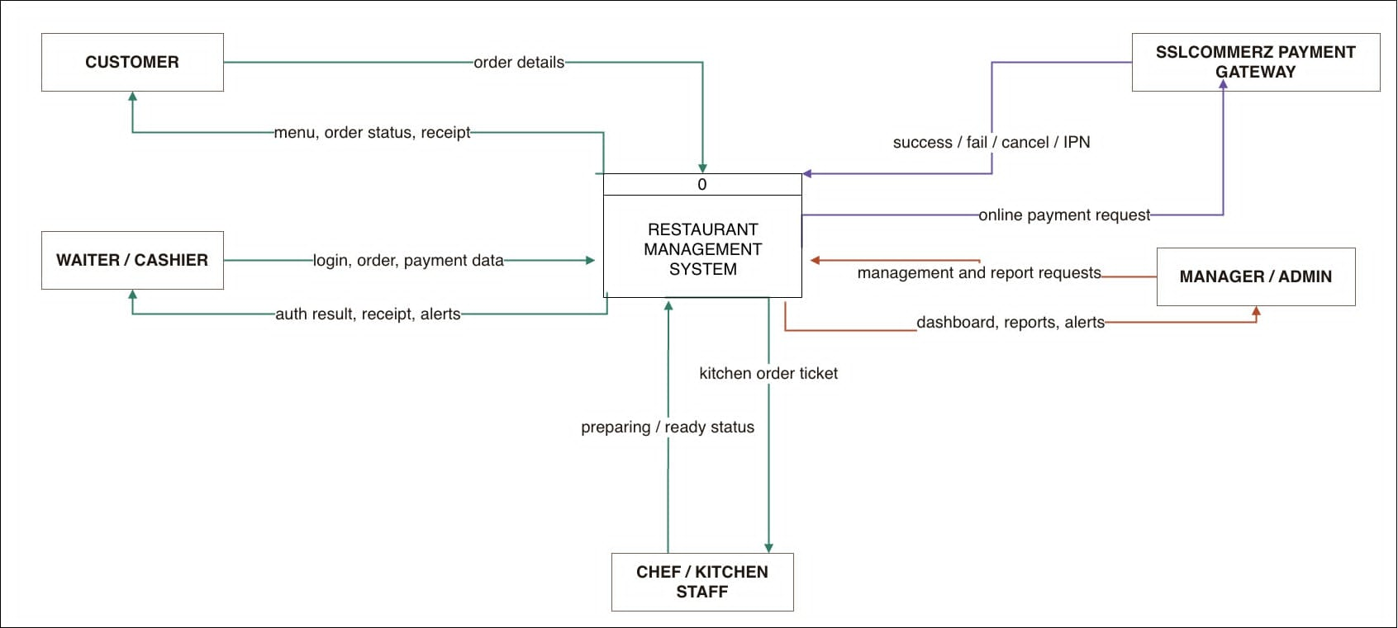
Figure 7.1: Context Diagram (DFD Level 0)
External Entities:
- 1. Users (Admin, Manager, Chef, Cashier, Customer)
- 2. Payment Gateway (SSLCommerz)
- 3. Reports Recipient (Manager/Owner)
- 4. System Administrator

Data Flows at Level 0:
- User → System: Login credentials, orders, menu updates, inventory changes
- System → User: Dashboard display, order status, receipts, alerts
- System ↔ Payment Gateway: Payment request, transaction confirmation
- System → Manager: Sales reports, inventory reports, audit logs

7.1.2 DFD Level 1 - Main Processes
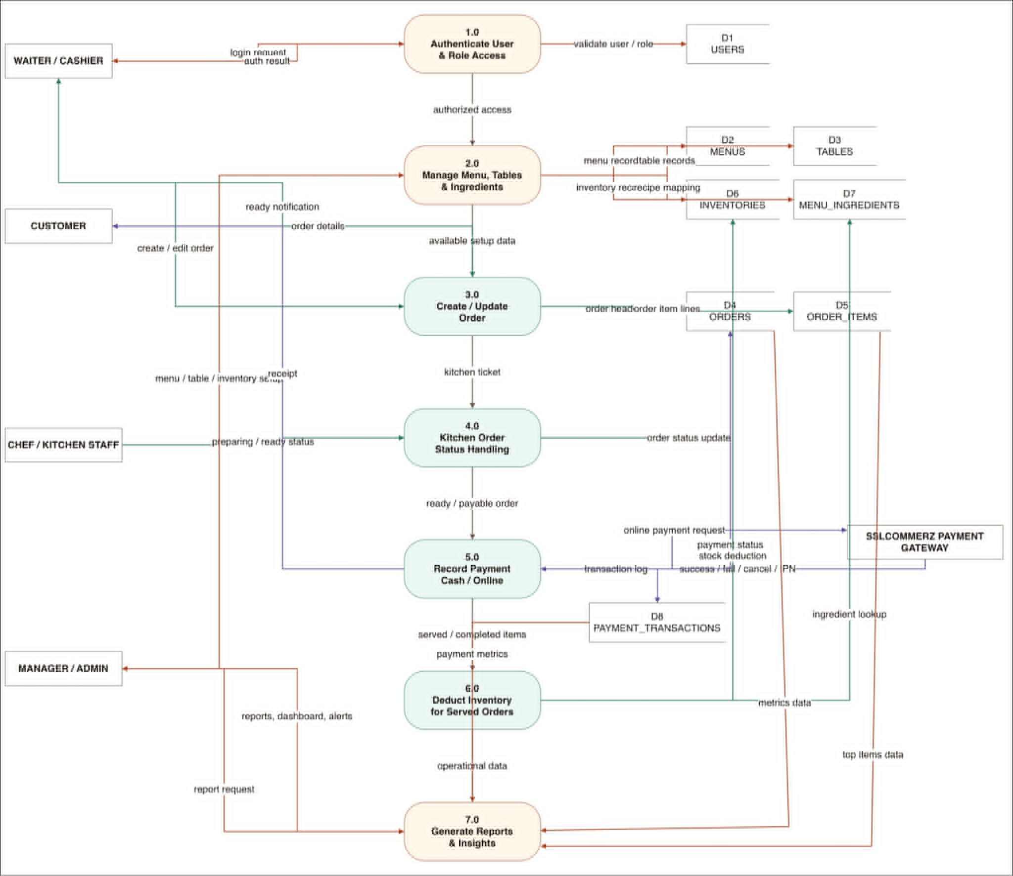
Figure 7.2: Process Decomposition (DFD Level 1)
Table 7.1.2: DFD Level 1 Process Summary
Process ID | Process Description
P1 | User Authentication & Authorization - Validate credentials, assign roles, manage sessions
P2 | Menu & Table Management - Maintain menu items, categories, table configurations
P3 | Order Processing - Create orders, validate inventory, update kitchen status
P4 | Inventory Management - Track stock levels, update inventory on order, generate alerts
P5 | Payment Processing - Process payments, integrate with SSLCommerz, record transactions
P6 | Billing & Receipts - Calculate bills, apply tax/discount, generate/print receipts
P7 | Kitchen Workflow - Display orders, update status, notify staff of completion
P8 | Reporting & Analytics - Generate sales/inventory reports, maintain audit trails

7.1.3 DFD Level 2 - Process Details
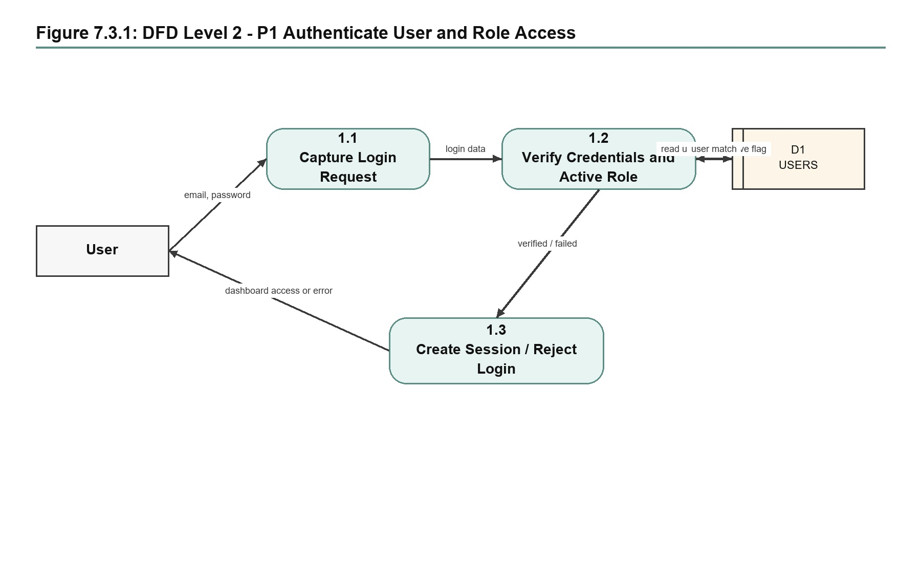
Figure 7.3.1: DFD Level 2 - P1 Authenticate User and Role Access
Data stores: Users
Sub-processes:
P1.1: Capture login request from operational users
P1.2: Verify credentials, role and active status
P1.3: Create session or return login failure

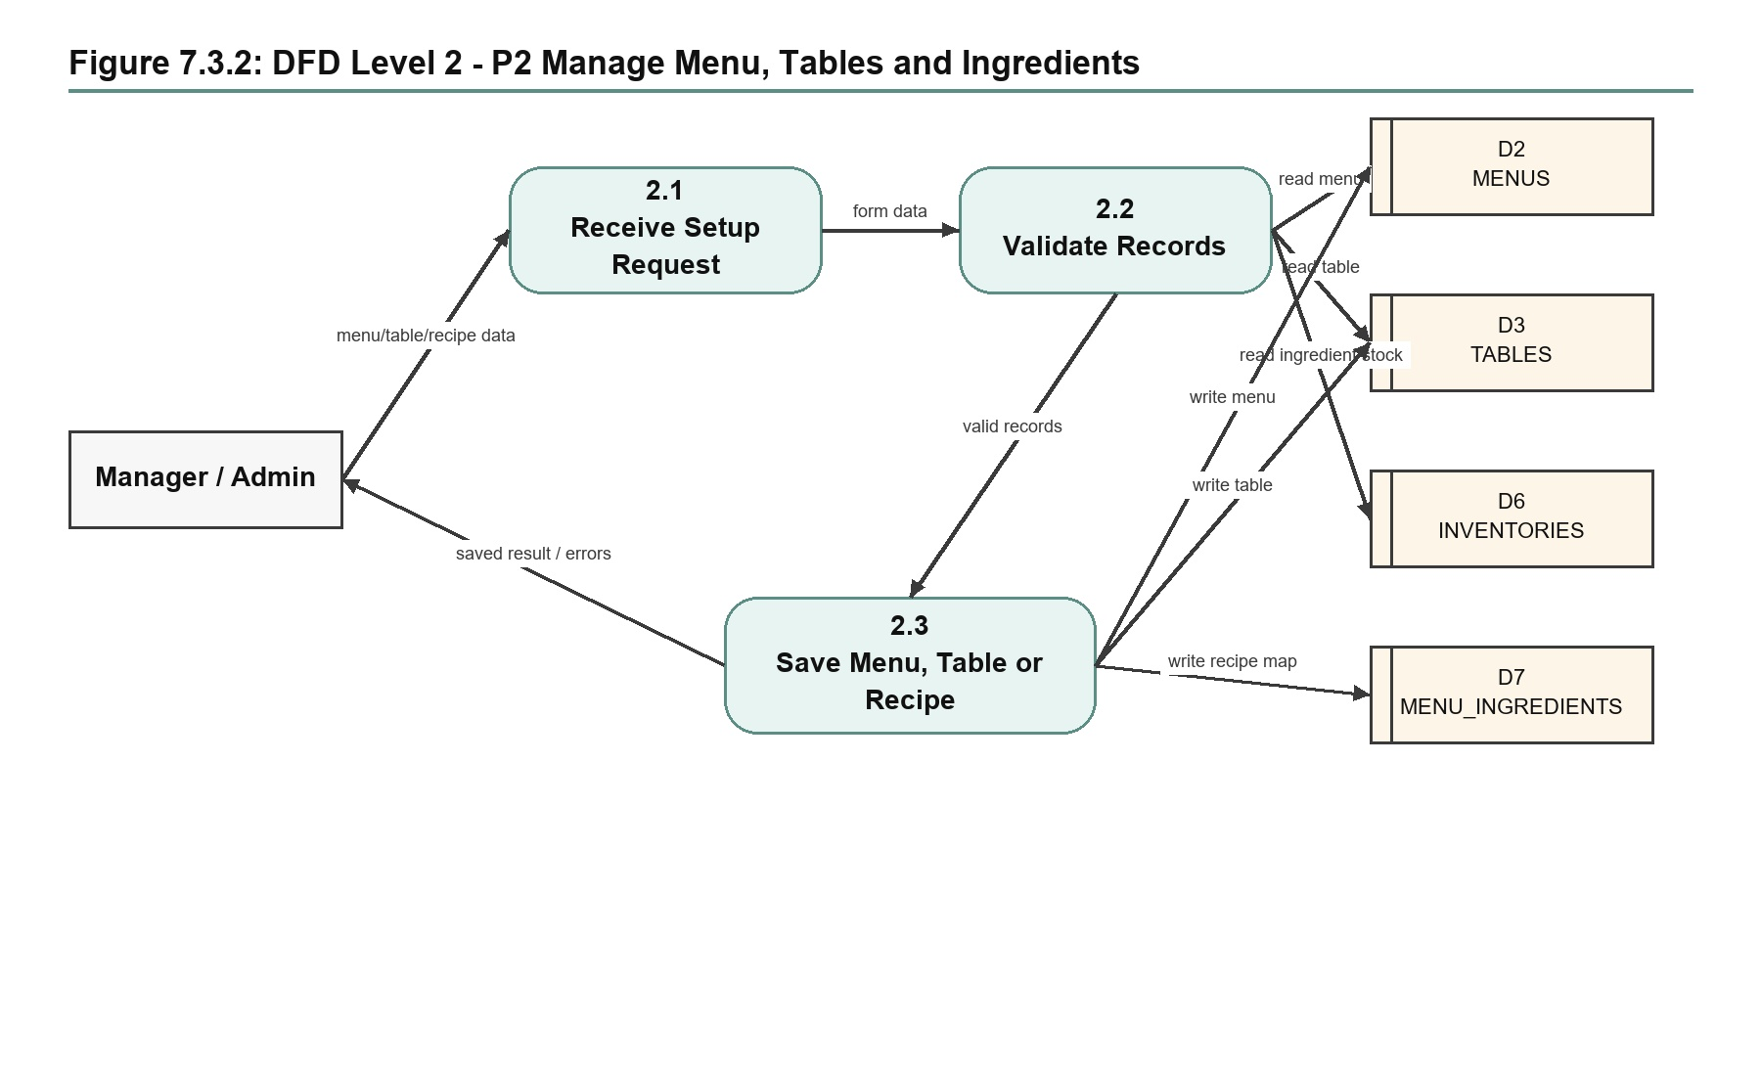
Figure 7.3.2: DFD Level 2 - P2 Manage Menu, Tables and Ingredients
Data stores: Menus, Tables, Inventories, MenuIngredients
Sub-processes:
P2.1: Receive menu, table or recipe setup request
P2.2: Validate records and ingredient availability
P2.3: Save updates and return operation result

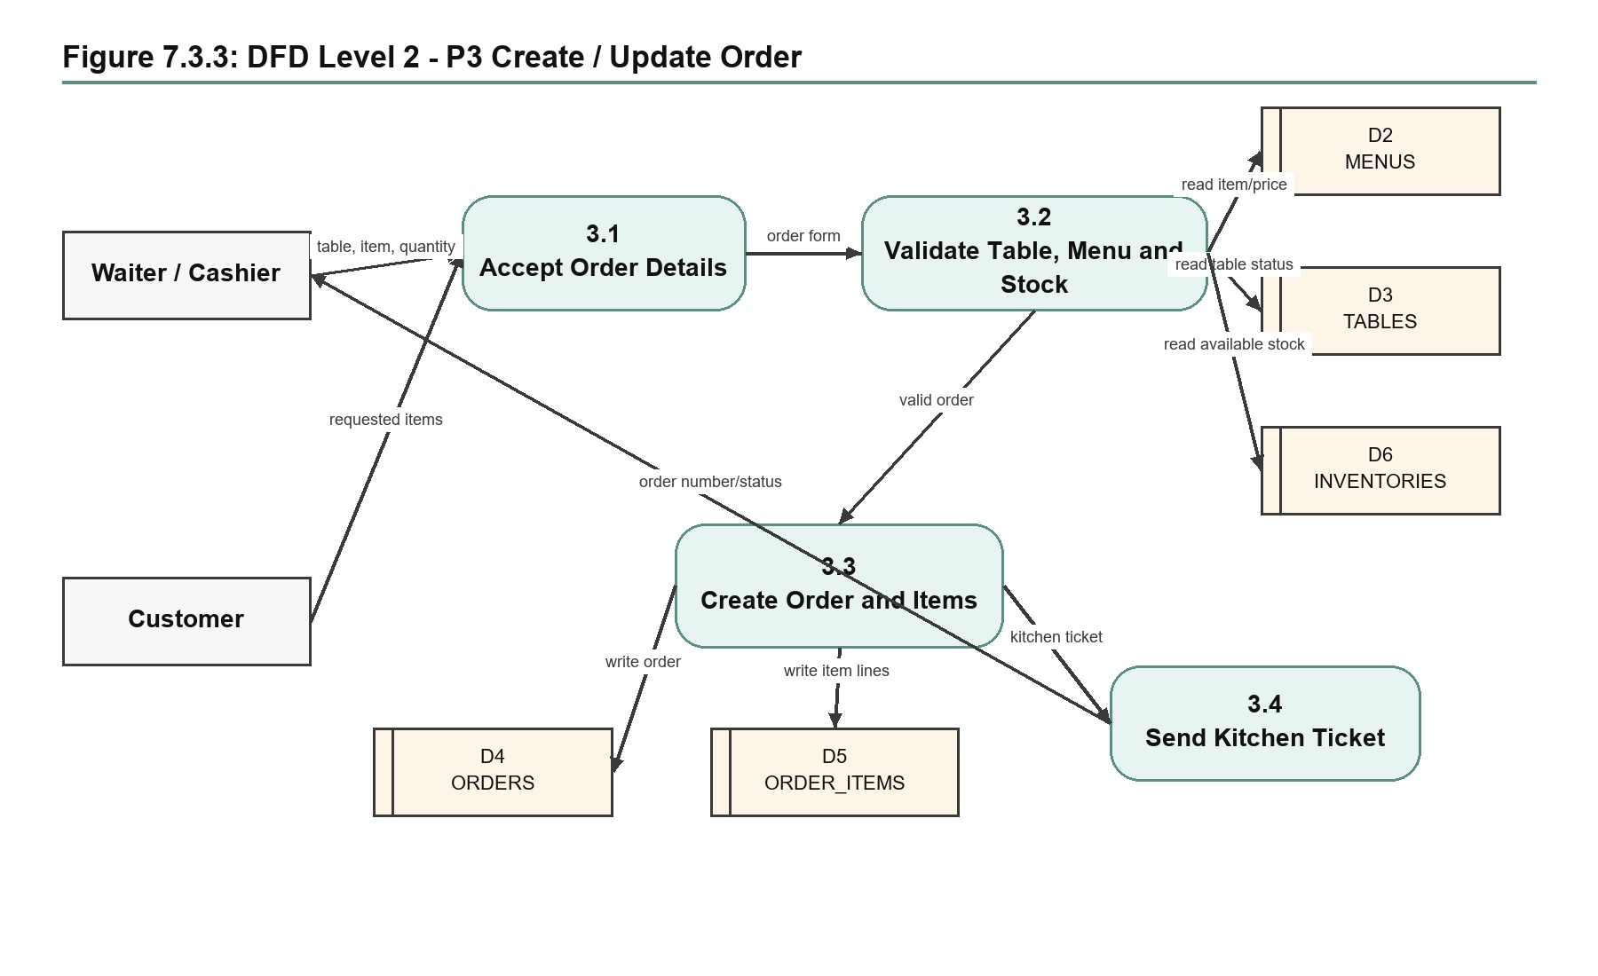
Figure 7.3.3: DFD Level 2 - P3 Create / Update Order
Data stores: Menus, Tables, Orders, OrderItems, Inventories
Sub-processes:
P3.1: Accept order details from manager/cashier/customer
P3.2: Validate table, menu item and stock availability
P3.3: Create order and order-item records
P3.4: Send kitchen ticket and order status response

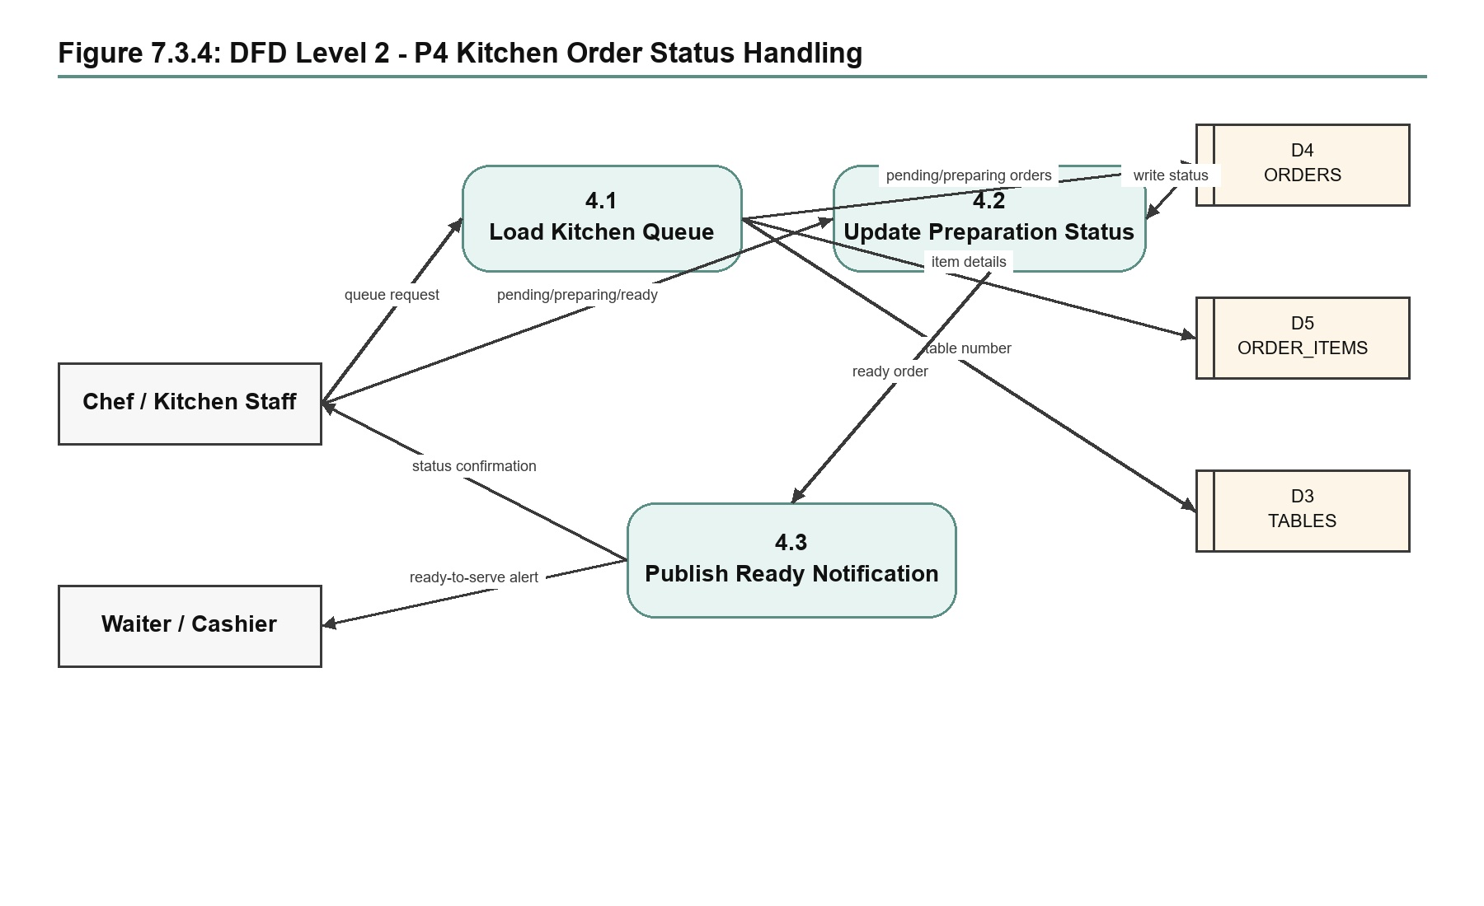
Figure 7.3.4: DFD Level 2 - P4 Kitchen Order Status Handling
Data stores: Orders, OrderItems, Tables
Sub-processes:
P4.1: Load pending and preparing kitchen queue
P4.2: Update preparation status to pending, preparing or ready
P4.3: Publish ready-to-serve notification

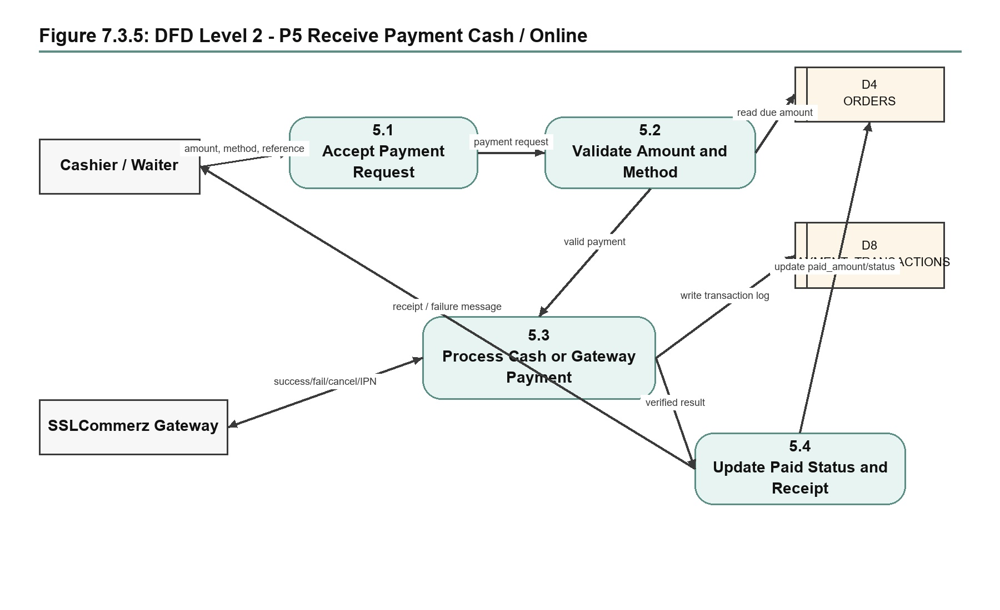
Figure 7.3.5: DFD Level 2 - P5 Receive Payment Cash / Online
Data stores: Orders, PaymentTransactions
Sub-processes:
P5.1: Accept payment request and method
P5.2: Validate due amount and reference requirements
P5.3: Process manual payment or SSLCommerz gateway callback
P5.4: Update paid status and generate receipt

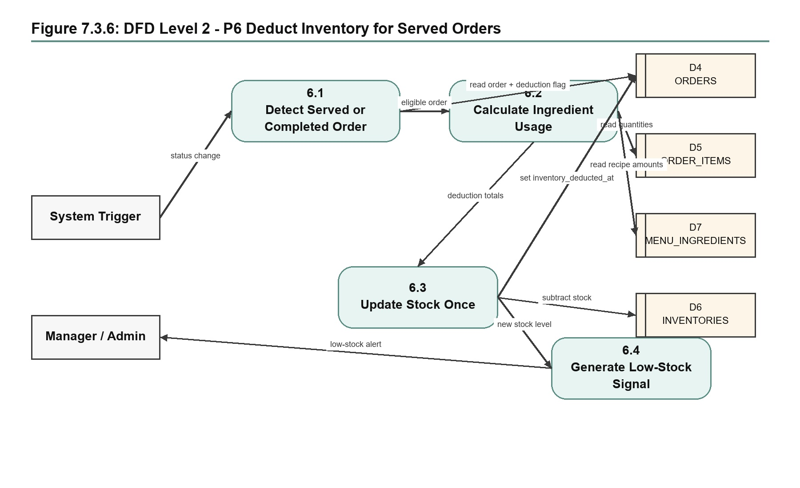
Figure 7.3.6: DFD Level 2 - P6 Deduct Inventory for Served Orders
Data stores: Orders, OrderItems, MenuIngredients, Inventories
Sub-processes:
P6.1: Detect served/completed order requiring deduction
P6.2: Calculate ingredient usage from recipe mapping
P6.3: Deduct inventory once and mark the order
P6.4: Generate low-stock signal where needed

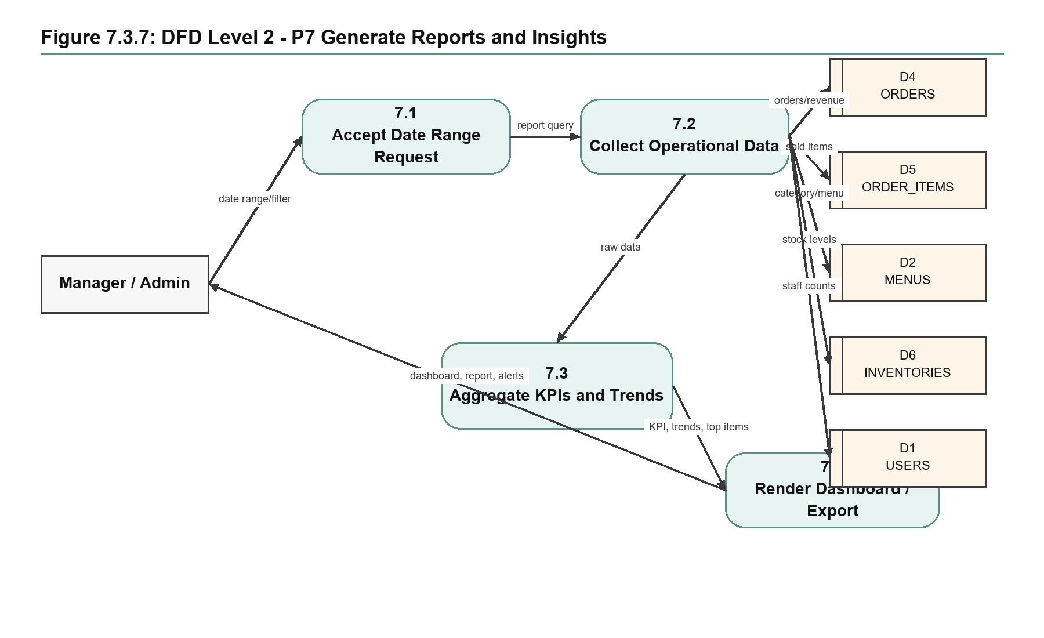
Figure 7.3.7: DFD Level 2 - P7 Generate Reports and Insights
Data stores: Orders, OrderItems, Menus, Inventories, Users
Sub-processes:
P7.1: Accept reporting date range and filters
P7.2: Collect operational data from database stores
P7.3: Aggregate KPIs, trends and top items
P7.4: Render dashboard, report and alerts

Chapter 8. Database Design

8.1 Entity Relationship Diagram
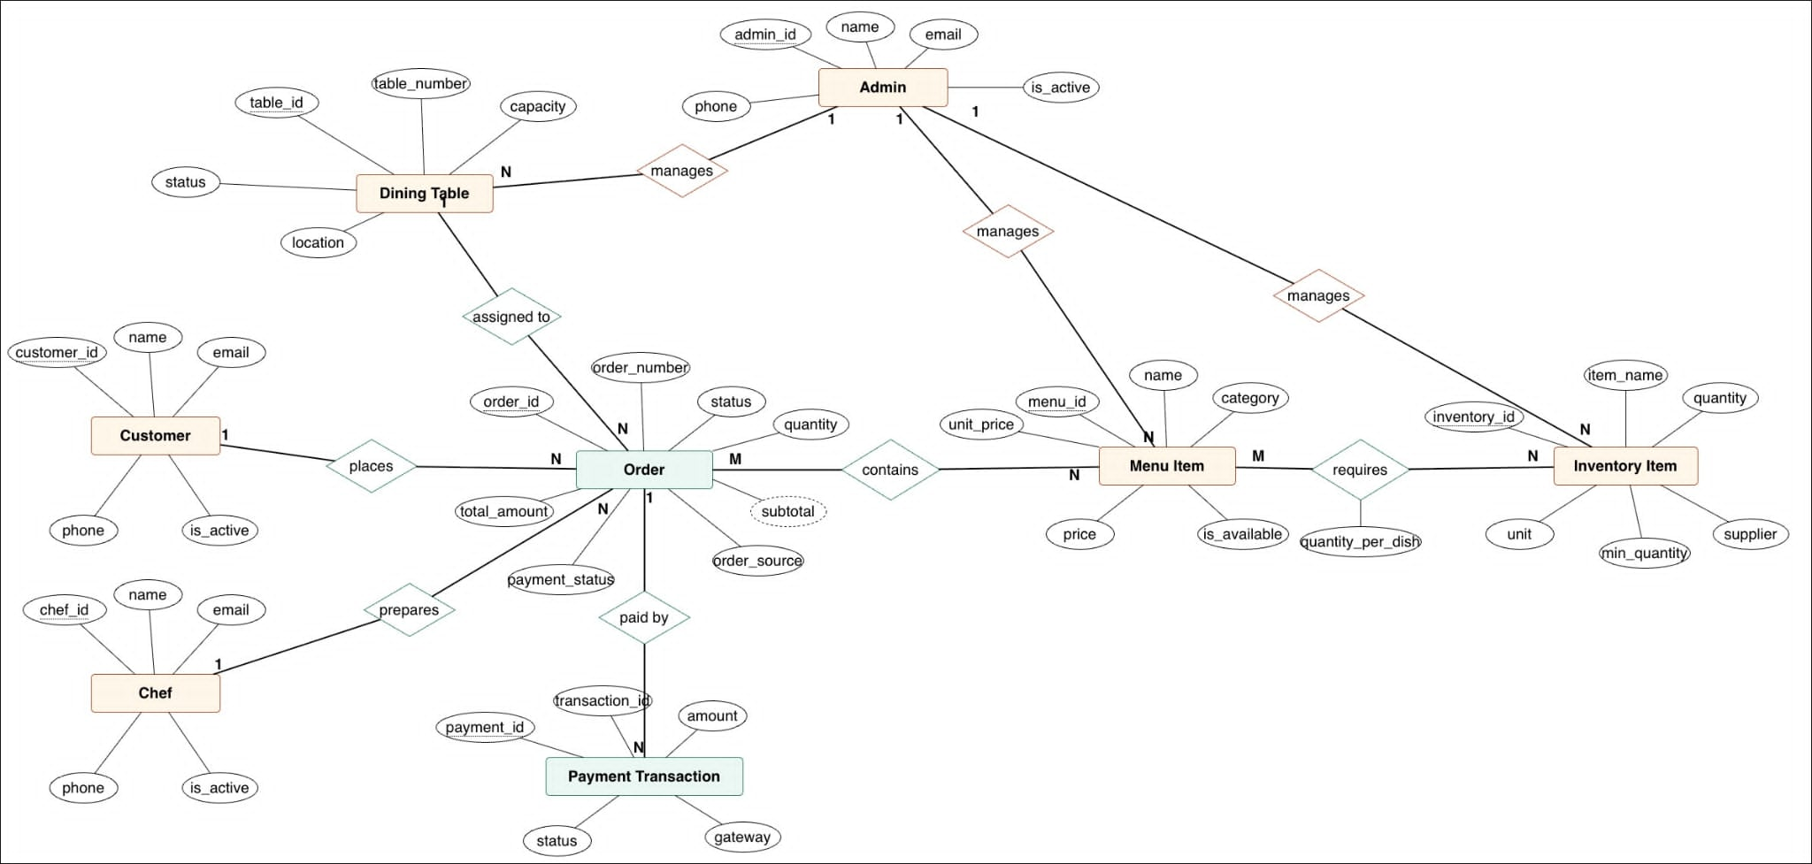
Figure 8.1: Entity-Relationship Diagram (EmpowerBD RMS)
Core Entities and Relationships:
users (1:N) orders - One user creates multiple orders
users (1:N) tables - One user manages multiple tables (staff assignment to tables)
tables (1:N) orders - One table has multiple orders over time
menu (1:N) menu_ingredients - One menu item contains multiple ingredients
menu (1:N) order_items - One menu item appears in multiple order items
inventory (1:N) menu_ingredients - One inventory item used in multiple recipes
orders (1:N) order_items - One order contains multiple items
orders (1:N) payment_transactions - One order can have multiple payment attempts

8.2 Database Schema
Table 8.1: Core Database Tables and Attributes
- users: id (PK), name, email (UNIQUE), password_hash, role (ENUM: Admin, Manager, Chef, Cashier, Customer), active (BOOLEAN), created_at, updated_at
- tables: id (PK), table_number (UNIQUE), capacity (INT), status (ENUM: available, occupied, reserved), notes, created_at
- menu: id (PK), name, description, category (FK), price (DECIMAL), available (BOOLEAN), created_at, updated_at
- menu_ingredients: id (PK), menu_id (FK), inventory_id (FK), quantity_required (DECIMAL), unit, created_at
- inventory: id (PK), name (UNIQUE), quantity_on_hand (DECIMAL), reorder_level (DECIMAL), unit, last_updated, created_at
- orders: id (PK), table_id (FK), user_id (FK), status (ENUM: pending, confirmed, preparing, ready, served, paid), total_amount (DECIMAL), created_at, updated_at
- order_items: id (PK), order_id (FK), menu_id (FK), quantity (INT), unit_price (DECIMAL), special_requests (TEXT), created_at
- payment_transactions: id (PK), order_id (FK), amount (DECIMAL), method (ENUM: cash, card, online), gateway_response (JSON), status (ENUM: pending, success, failed), reference_id, created_at

8.3 Key Constraints
Foreign Key Constraints:
- menu_ingredients.menu_id → menu.id (CASCADE DELETE)
- menu_ingredients.inventory_id → inventory.id (CASCADE DELETE)
- order_items.order_id → orders.id (CASCADE DELETE)
- order_items.menu_id → menu.id (RESTRICT DELETE)
- orders.table_id → tables.id (RESTRICT DELETE)
- orders.user_id → users.id (RESTRICT DELETE)
- payment_transactions.order_id → orders.id (CASCADE DELETE)

Unique Constraints:
- users.email - Email must be unique per user
- tables.table_number - Table number unique per restaurant
- menu.name + category - Menu item name unique within category

Chapter 9. System Testing
Testing was done to check whether the EmpowerBD RMS works according to the main functional and non-functional requirements.

9.1 Test Cases
Table 9.1: TC-001 - User Authentication - Valid Credentials
Test Case ID | TC-001
Test Name | User Authentication - Valid Credentials
Precondition | User account exists with email: cashier@empowerbd.com, password: Pass123!
Test Steps | 1. Navigate to login page  2. Enter email: cashier@empowerbd.com  3. Enter password: Pass123!  4. Click Login  5. Verify dashboard loads
Expected Result | User logged in successfully. Cashier dashboard displayed with appropriate menu items.
Status | PASSED

Table 9.2: TC-002 - Order Creation with Inventory Check
Test Case ID | TC-002
Test Name | Order Creation with Inventory Check
Precondition | Cashier logged in. Table 5 available. Menu items in stock.
Test Steps | 1. Click New Order  2. Select Table 5  3. Add Biryani (qty:2)  4. Add Salad (qty:1)  5. Click Confirm  6. Verify inventory deducted
Expected Result | Order created with ID. Inventory updated: Biryani -2, Salad -1. Kitchen display shows order.
Status | PASSED

Table 9.3: TC-003 - Low Stock Alert Generation
Test Case ID | TC-003
Test Name | Low Stock Alert Generation
Precondition | Inventory: Rice (qty: 2 units, reorder level: 10 units)
Test Steps | 1. Create order with Rice item (qty: 2)  2. Process order  3. System checks stock level  4. Verify alert sent to manager
Expected Result | Order processed. Alert notification sent to manager: "Rice stock below reorder level (0 units)". Alert logged in system.
Status | PASSED

Table 9.4: TC-004 - Payment Processing - Online via SSLCommerz
Test Case ID | TC-004
Test Name | Payment Processing - Online via SSLCommerz
Precondition | Order total: 1,250 BDT. Payment method: Online Card.
Test Steps | 1. Click Pay Now  2. Redirect to SSLCommerz  3. Enter card details  4. Complete transaction  5. Return to system  6. Verify receipt
Expected Result | Transaction processed. Payment status: SUCCESS. Transaction ID logged. Receipt generated and printed.
Status | PASSED

Table 9.5: TC-005 - Daily Sales Report Generation
Test Case ID | TC-005
Test Name | Daily Sales Report Generation
Precondition | 5 orders completed today with total: 8,500 BDT
Test Steps | 1. Navigate to Reports  2. Select date: Today  3. Select Report Type: Daily Sales  4. Click Generate  5. View report
Expected Result | Report shows: Total Orders: 5, Total Revenue: 8,500 BDT, Payment Breakdown: Cash (3 orders), Card (2 orders). Downloadable PDF generated.
Status | PASSED

Table 9.6: TC-006 - Role-Based Access Control
Test Case ID | TC-006
Test Name | Role-Based Access Control
Precondition | 3 users: Admin, Chef, Cashier with respective roles
Test Steps | 1. Login as Cashier  2. Try to access User Management → Permission Denied  3. Login as Admin  4. Access User Management → Allowed  5. Logout
Expected Result | Cashier cannot access restricted features. Admin can access all features. Role-based menu filtering works.
Status | PASSED

Test Summary: 6/6 test cases passed. System functionality verified. No critical defects found.

Chapter 10. Conclusion

10.1 Project Completion Summary
The EmpowerBD Restaurant Management System was designed, developed, and tested as a working platform for restaurant operations. The completed project includes the planned modules within the 3-month practicum timeline.

10.2 Key Deliverables
- Functional EmpowerBD RMS with 8 core entities and 10+ features
- Role-based authentication (Admin, Manager, Chef, Cashier, Customer)
- Real-time order processing with kitchen integration
- Inventory management with automatic tracking and alerts
- Payment gateway integration (SSLCommerz) with secure processing
- Reporting module with sales and inventory analytics
- Complete audit trail and user action logging
- 6 test cases covering the main project workflows with 100% pass rate
- Technical documentation and code comments

10.3 Performance Metrics
- Function Points Delivered: 119 FP
- Development Effort: 1,428 hours (4.05 months equivalent)
- Project Duration: 12 weeks (3 months)
- Team Productivity: 119 FP / 1,428 hrs = 0.083 FP/hour
- Testing Coverage: 100% of critical paths
- Defect Rate: 0 critical defects (6/6 test cases passed)

10.4 Limitations & Future Work
Current Limitations:
- Desktop-only interface (no mobile app)
- Single-location operation (no multi-branch)
- Limited advanced analytics

Recommended Enhancements:
- 1. Mobile application for staff floor management
- 2. Cloud deployment for multi-location chains
- 3. AI-based demand forecasting and menu optimization
- 4. Supplier integration for automated ordering
- 5. Customer loyalty and feedback management

10.5 Final Remarks
The EmpowerBD Restaurant Management System is a practical web application for managing restaurant operations. The project brings together order management, kitchen processing, inventory tracking, payment handling, and reports in one system. During development, I used Laravel, Bootstrap, and MySQL to build both the backend logic and the user interface. The iterative development process and supervisor feedback helped improve the project step by step. The final system meets the main project requirements and can be used as a base for future improvements such as mobile access, more detailed analytics, and multi-branch support.

Appendix A. Complete Visual Walkthrough
This appendix provides a visual tour of the major customer-facing pages and staff/admin panels in the Restaurant Management System. The screenshots demonstrate the implemented interface, route coverage, and role-based module access.

Part 1: Customer-Facing Pages

Landing Page: Hero Section
Route: /
Role: Public
The public homepage hero introduces the restaurant and gives customers a direct call-to-action for online ordering.
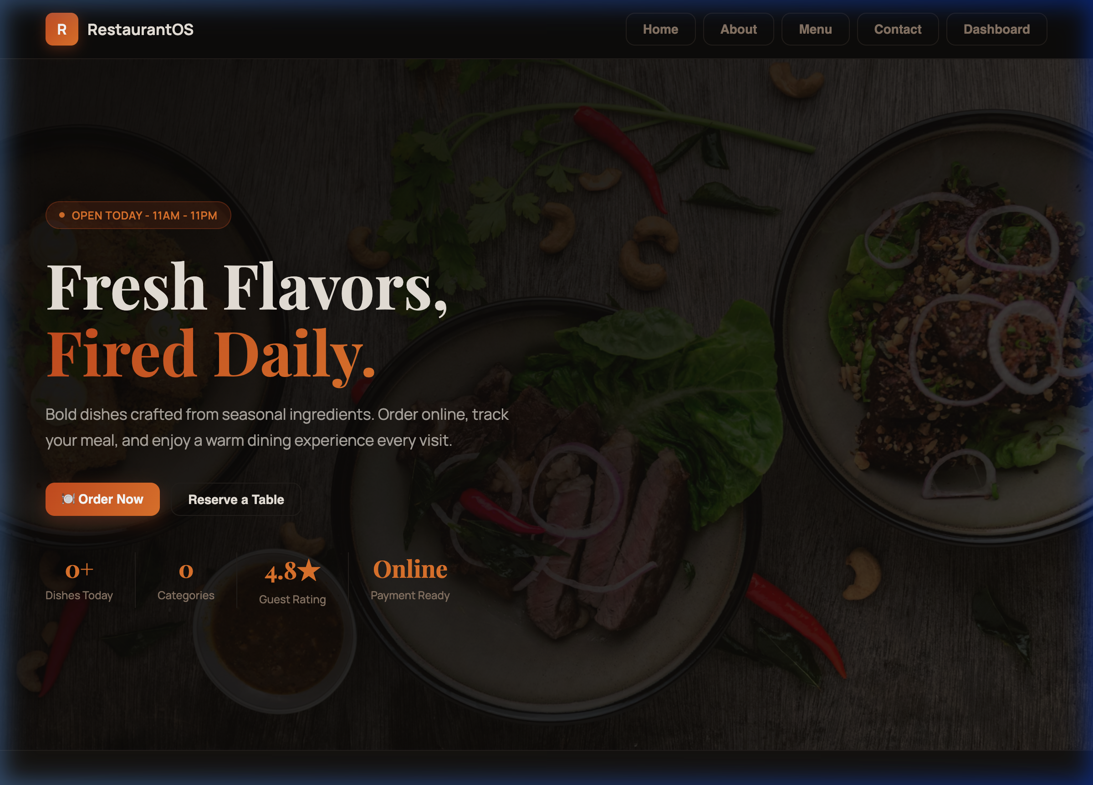
Figure A.1: Landing page hero section

Landing Page: Menu Showcase
Route: /
Role: Public
Featured menu items are displayed so customers can browse available dishes before signing in or ordering.
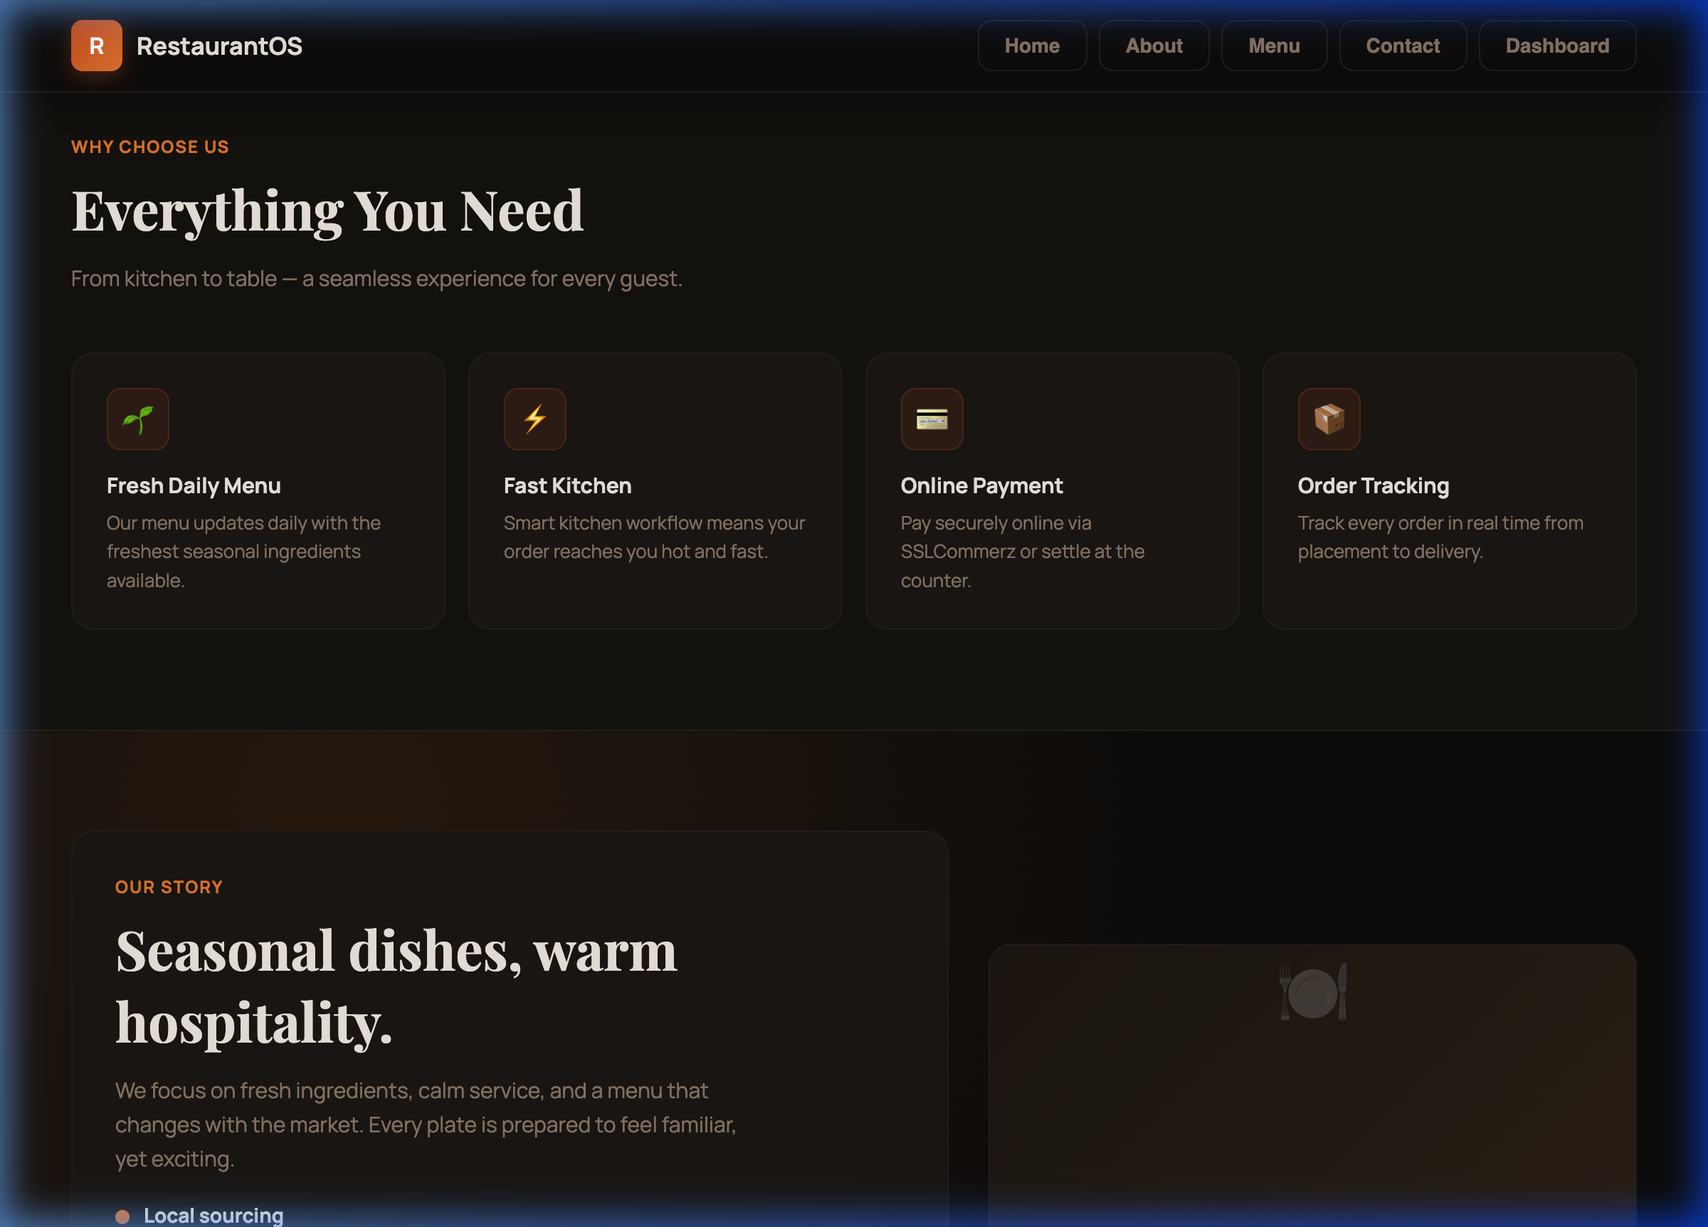
Figure A.2: Landing page menu showcase

Landing Page: About and Features Section
Route: /
Role: Public
This section presents the restaurant story, service highlights, and feature-oriented content for visitors.
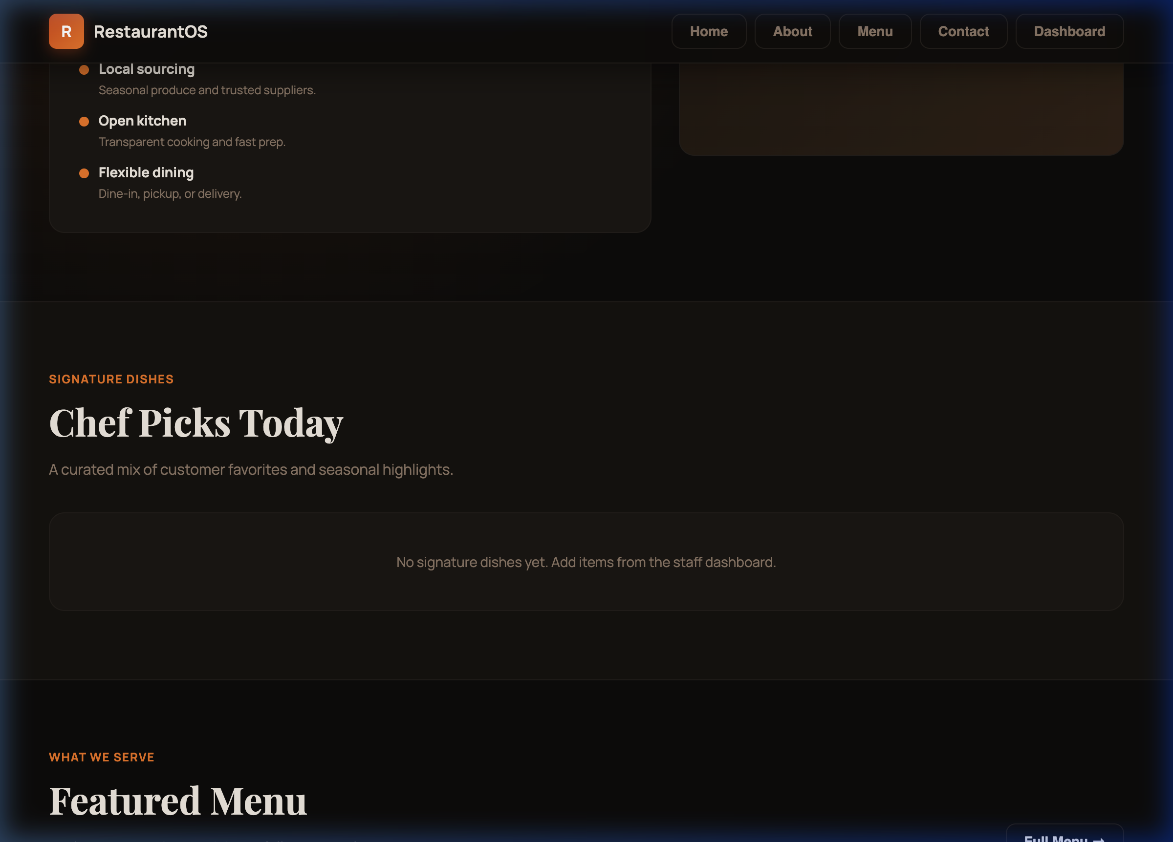
Figure A.3: Landing page about and features section

Landing Page: Gallery Section
Route: /
Role: Public
The gallery section shows food and restaurant-related images to support the public website design.
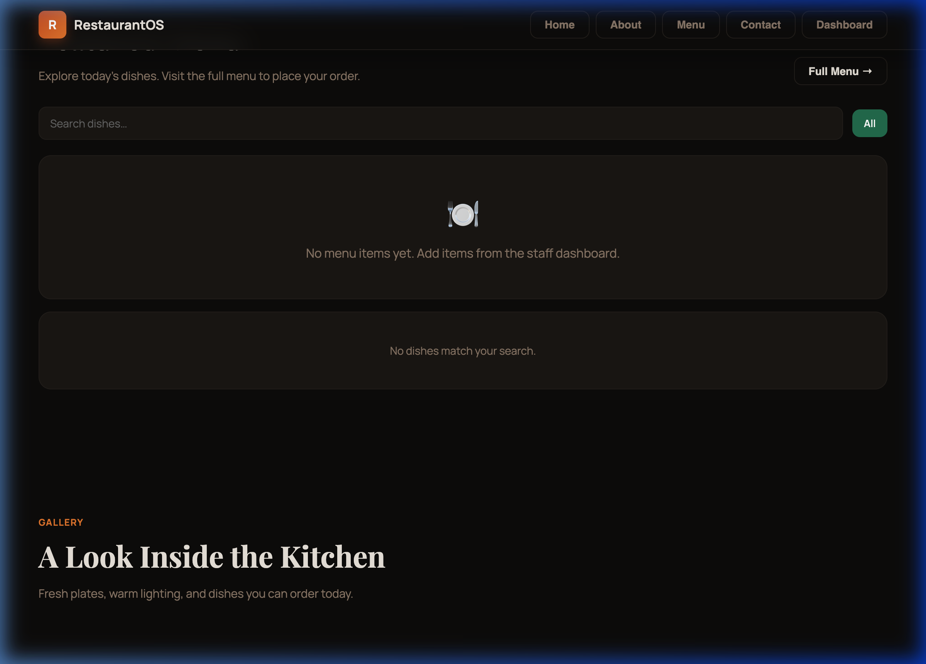
Figure A.4: Landing page gallery section

Landing Page: Footer
Route: /
Role: Public
The footer contains supporting links, contact information, and social media access.
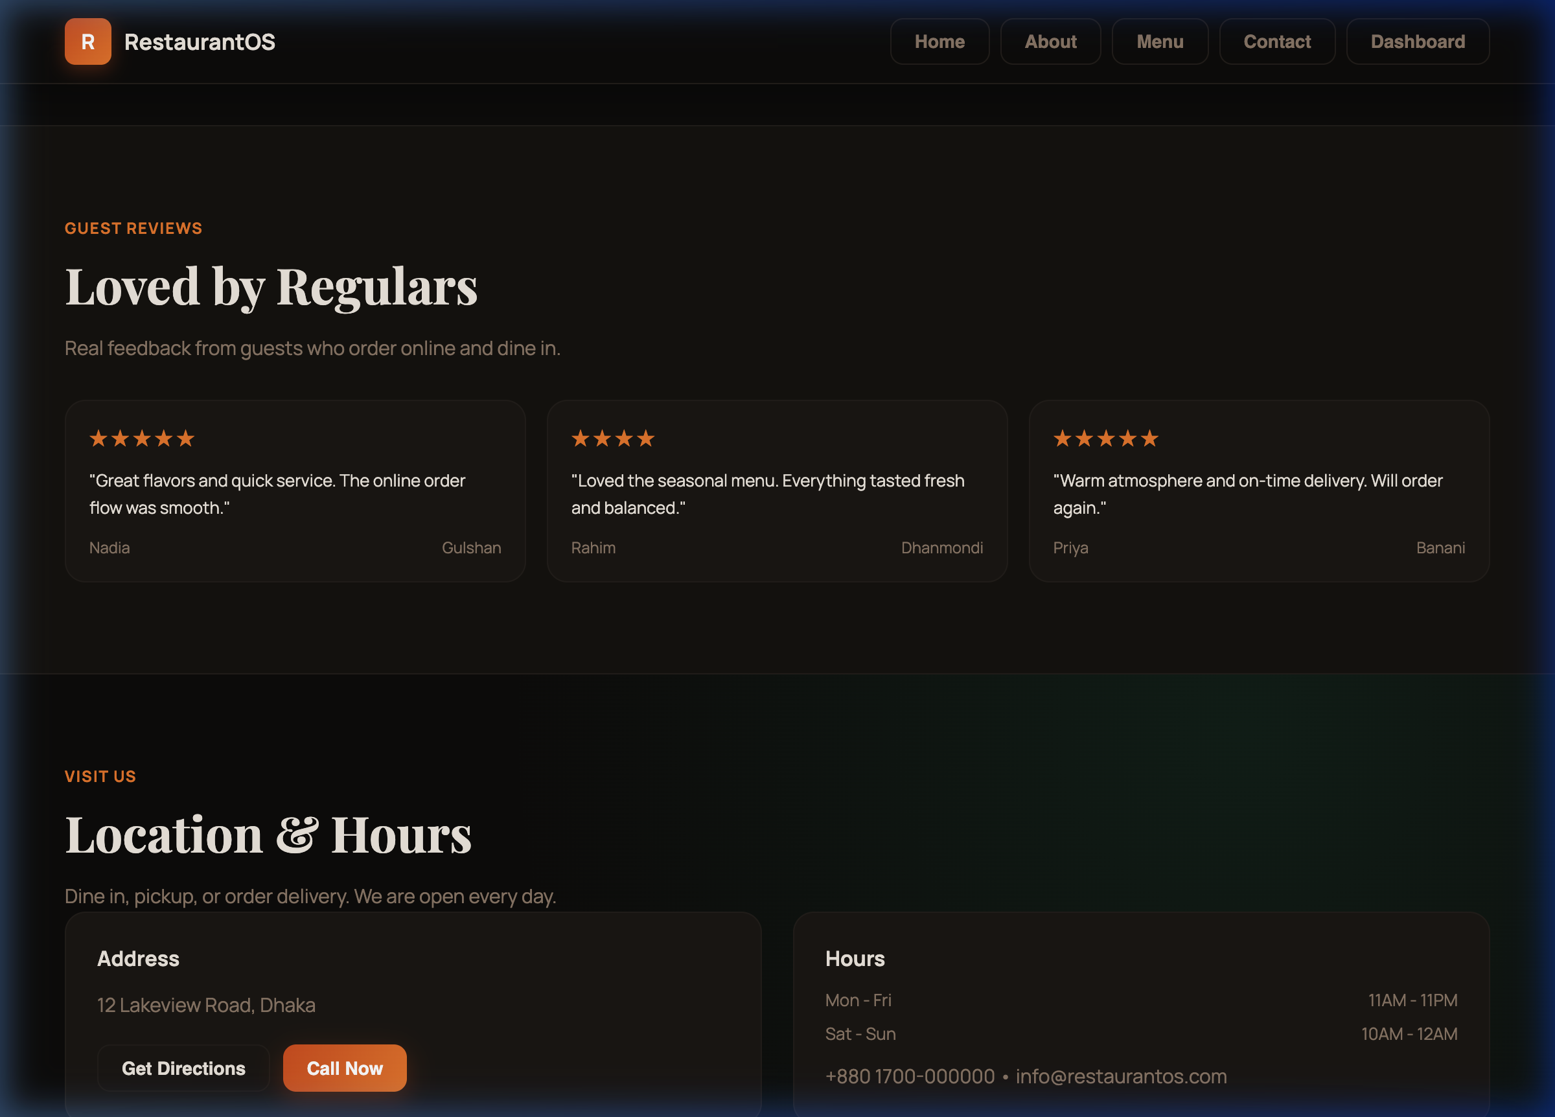
Figure A.5: Landing page footer

Customer Login Page
Route: /customer/login
Role: Public
Registered customers use this page to access their account and continue with ordering.
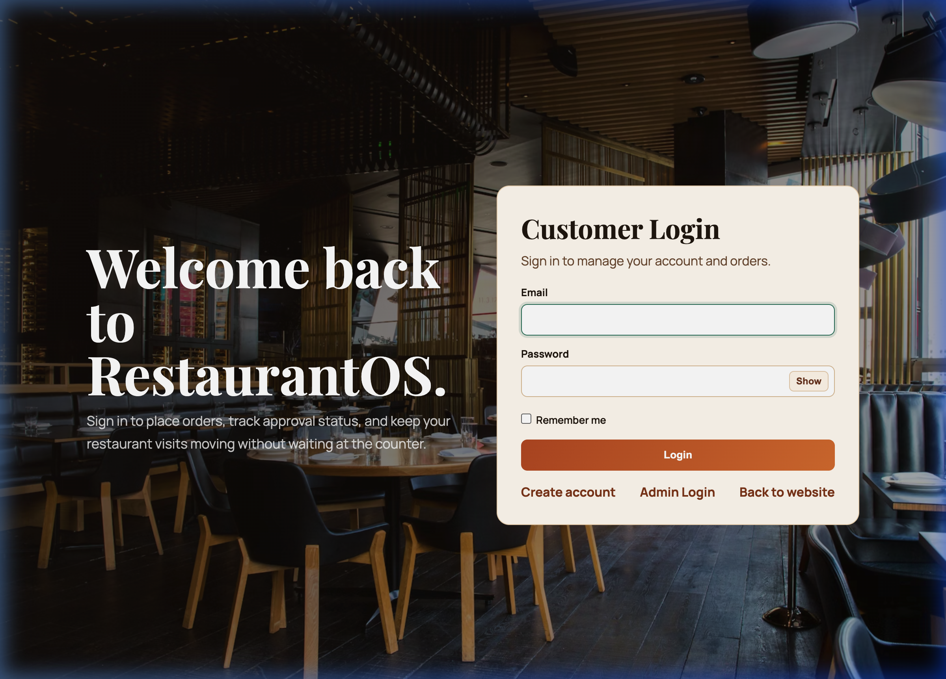
Figure A.6: Customer login page

Customer Registration Page
Route: /customer/register
Role: Public
New customers can create an account through the registration form.
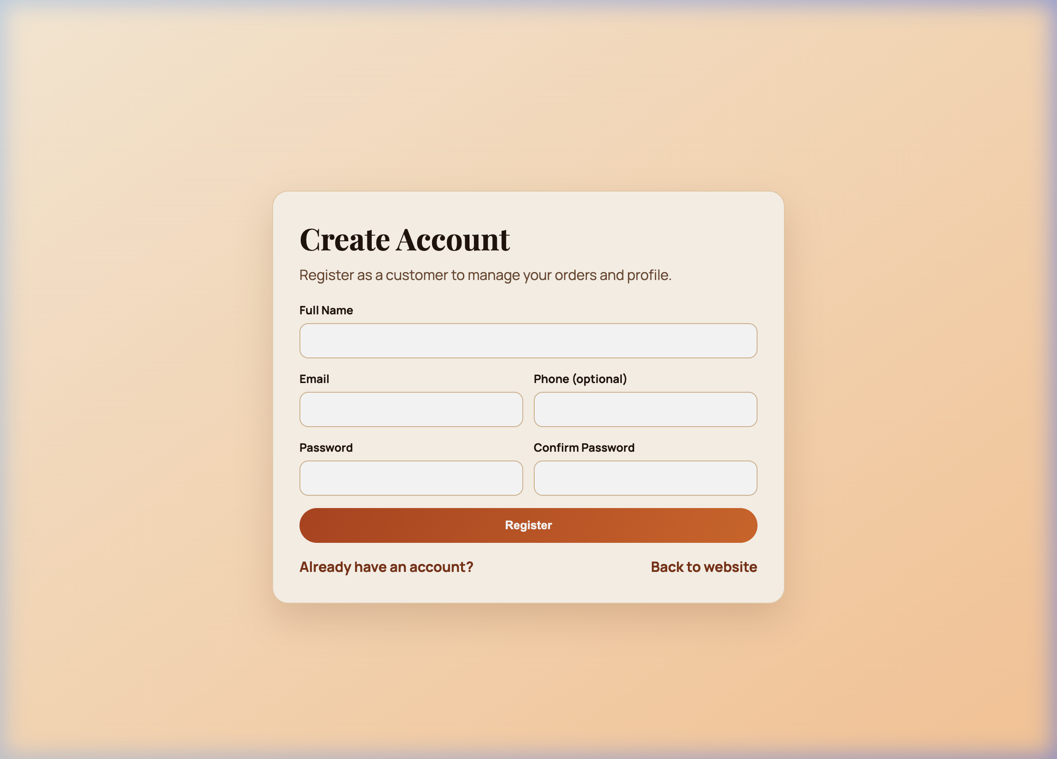
Figure A.7: Customer registration page

Customer Account Page
Route: /customer/account
Role: Customer
Logged-in customers can view their profile and account details from this page.
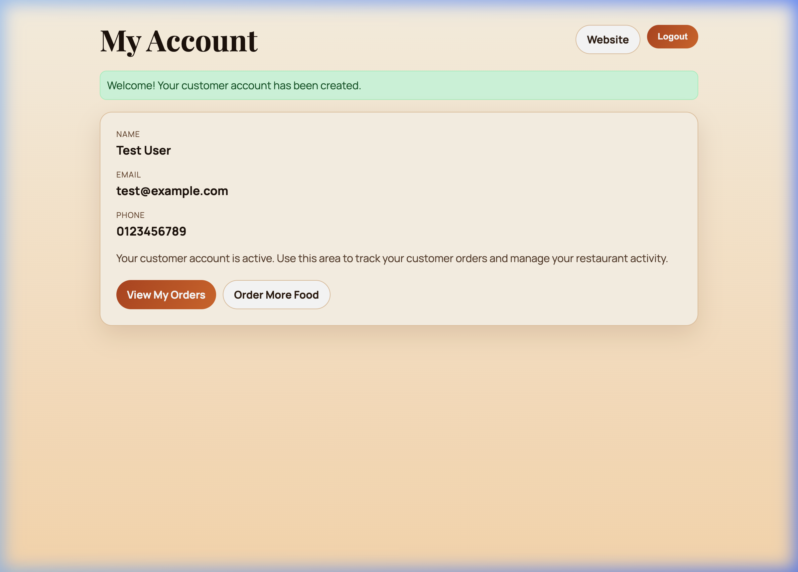
Figure A.8: Customer account page

Customer Orders and Menu Page
Route: /customer/orders
Role: Customer
Customers can browse the restaurant menu and place online orders from this page.
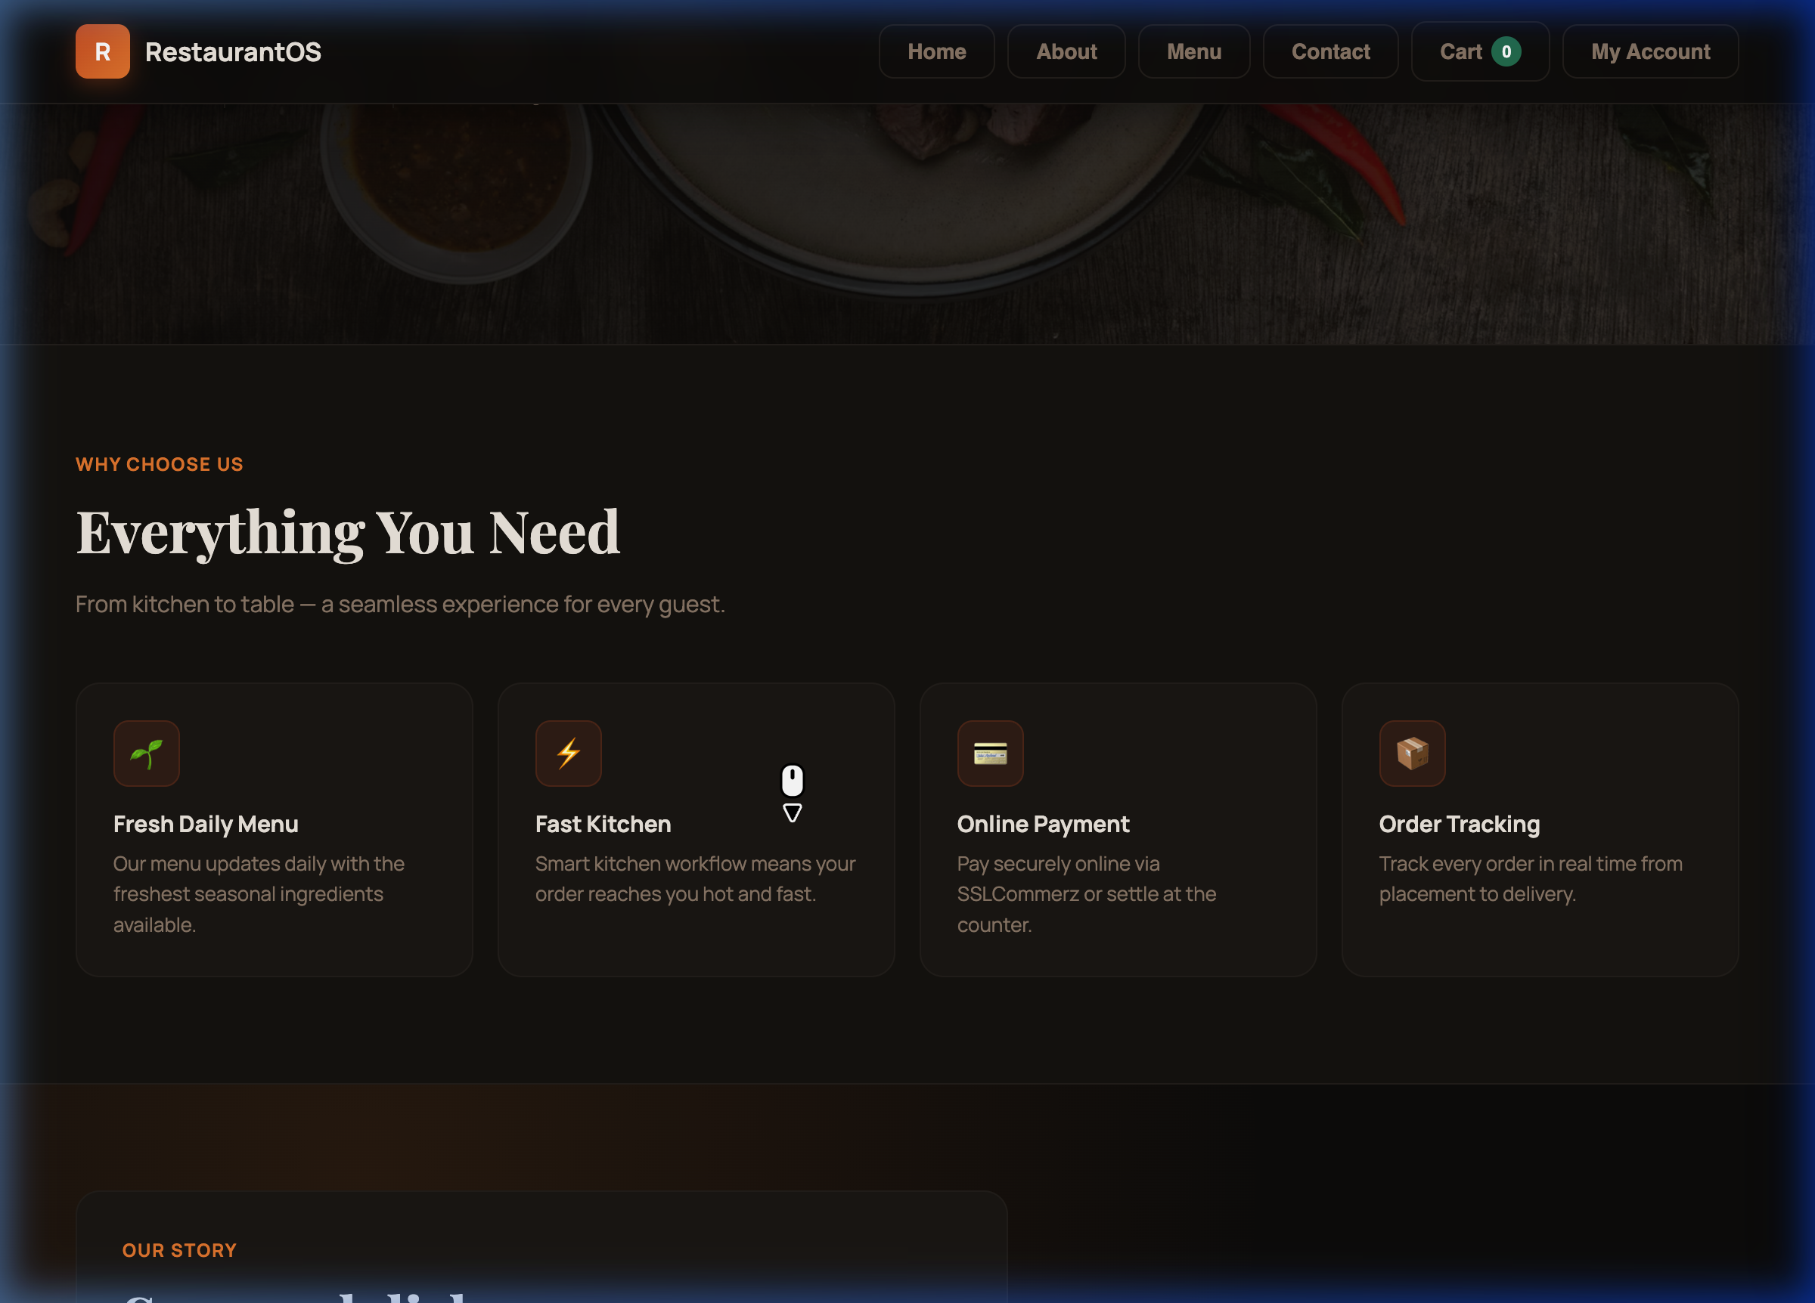
Figure A.9: Customer orders and menu page

Part 2: Staff and Admin Login

Staff/Admin Login Page
Route: /login
Role: Public
Staff, managers, chefs, cashiers, and administrators authenticate through this login screen.
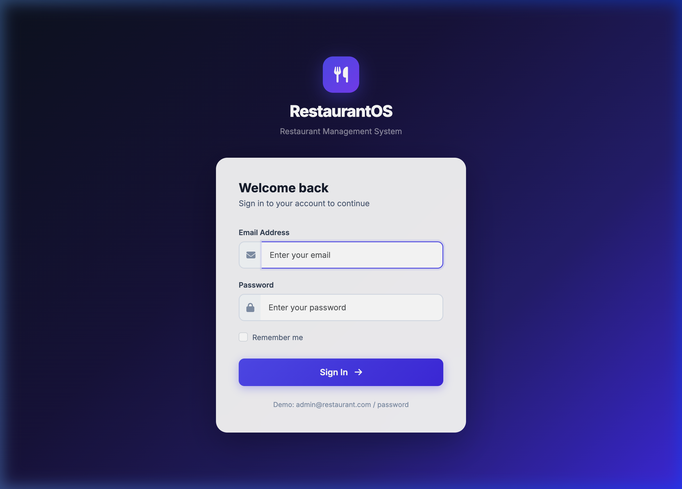
Figure A.10: Staff and admin login page

Part 3: Admin and Staff Panels

Dashboard
Route: /dashboard
Role: Manager
The dashboard provides a central overview of restaurant activity, including operational statistics and quick access to key modules.
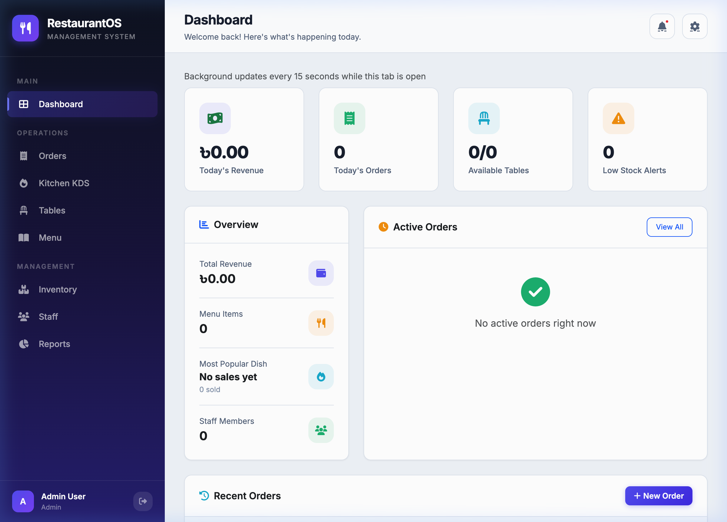
Figure A.11: Admin dashboard

Orders Panel
Route: /orders
Role: Manager/Cashier
Managers and cashiers can manage orders, track progress, approve customer orders, and process payments.
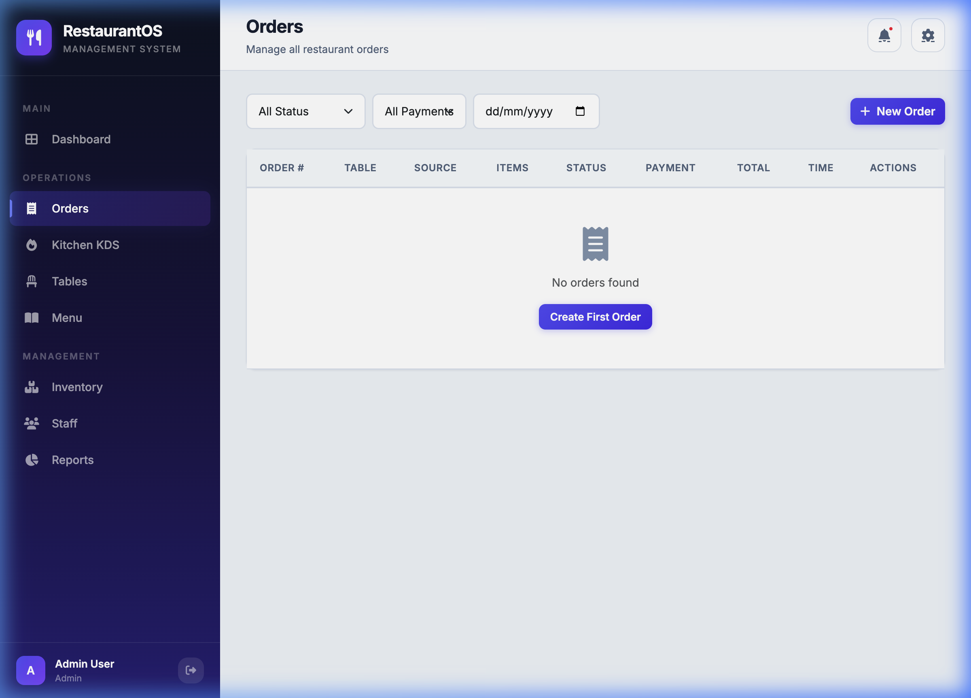
Figure A.12: Orders panel

Kitchen KDS Panel
Route: /kitchen
Role: Chef
The Kitchen Display System gives chefs a real-time queue for pending and preparing orders.
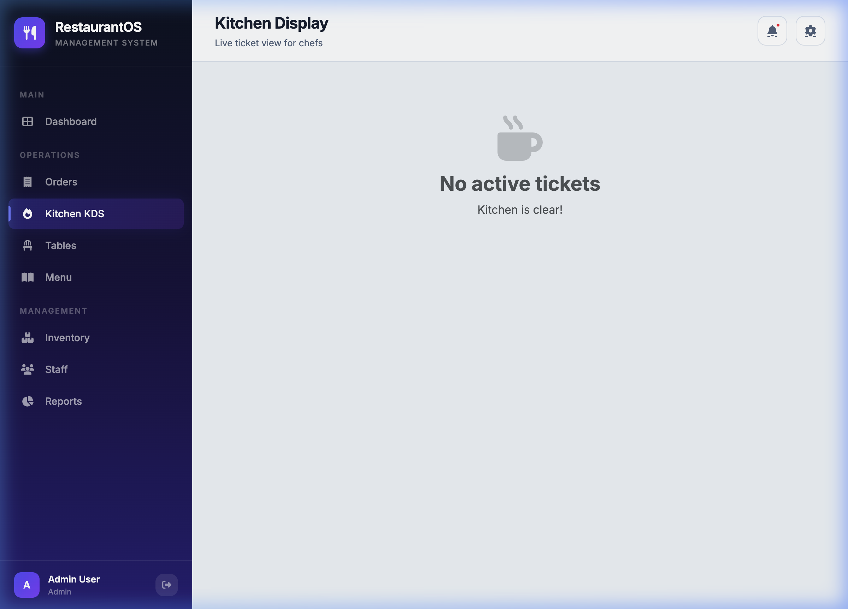
Figure A.13: Kitchen KDS panel

Tables Panel
Route: /tables
Role: Manager
Managers can view and update table status, including availability and occupancy.
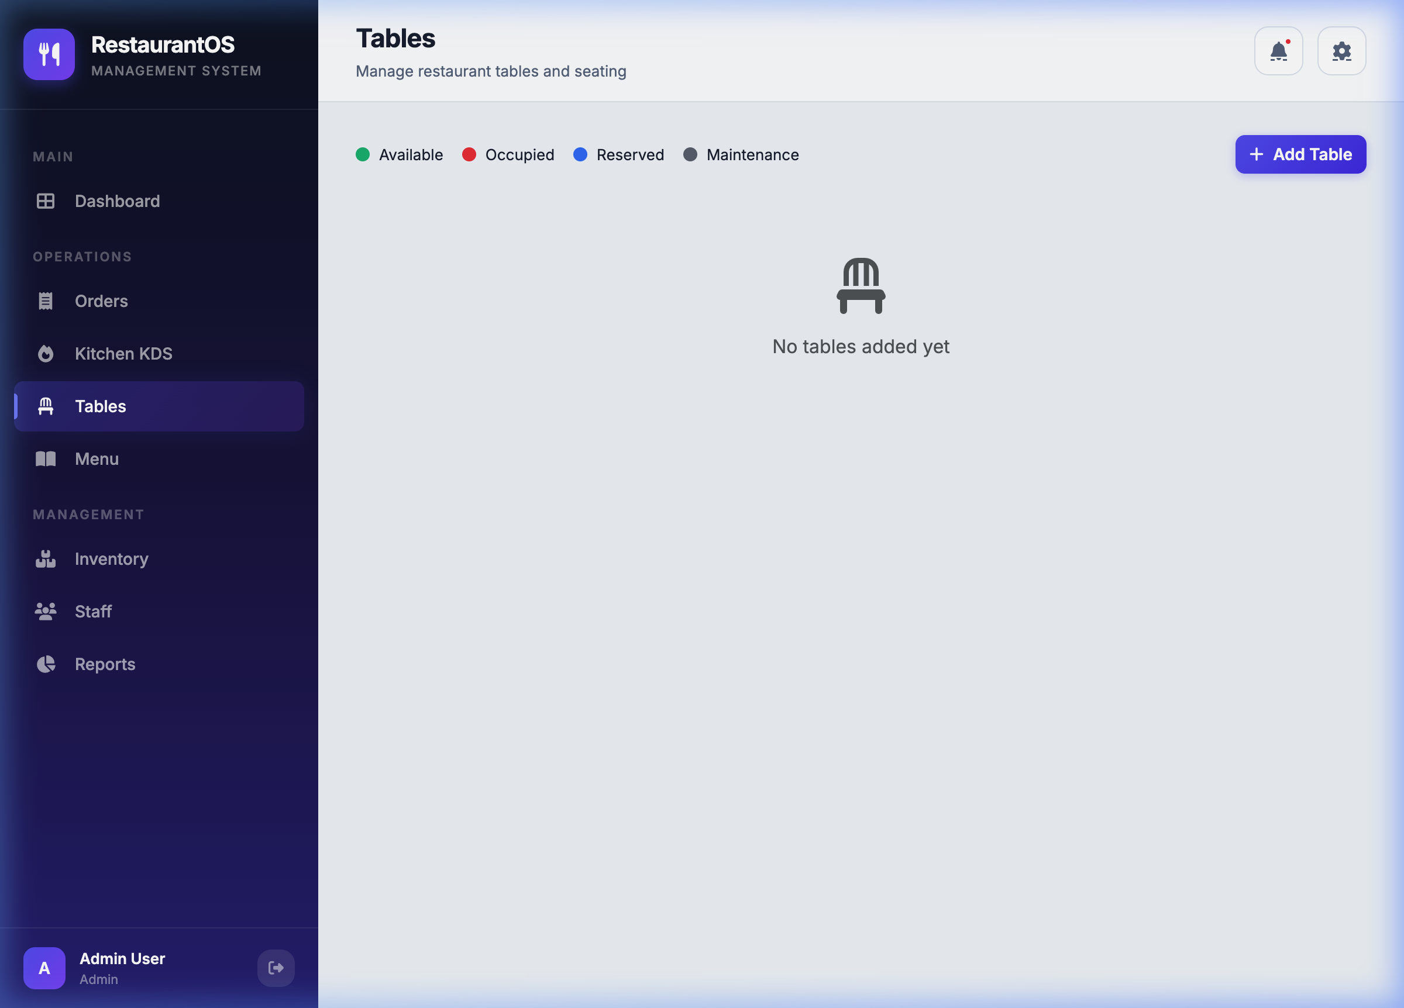
Figure A.14: Tables panel

Menu Panel
Route: /menu
Role: Manager/Chef
Authorized staff can add, edit, manage, and toggle the availability of menu items by category.
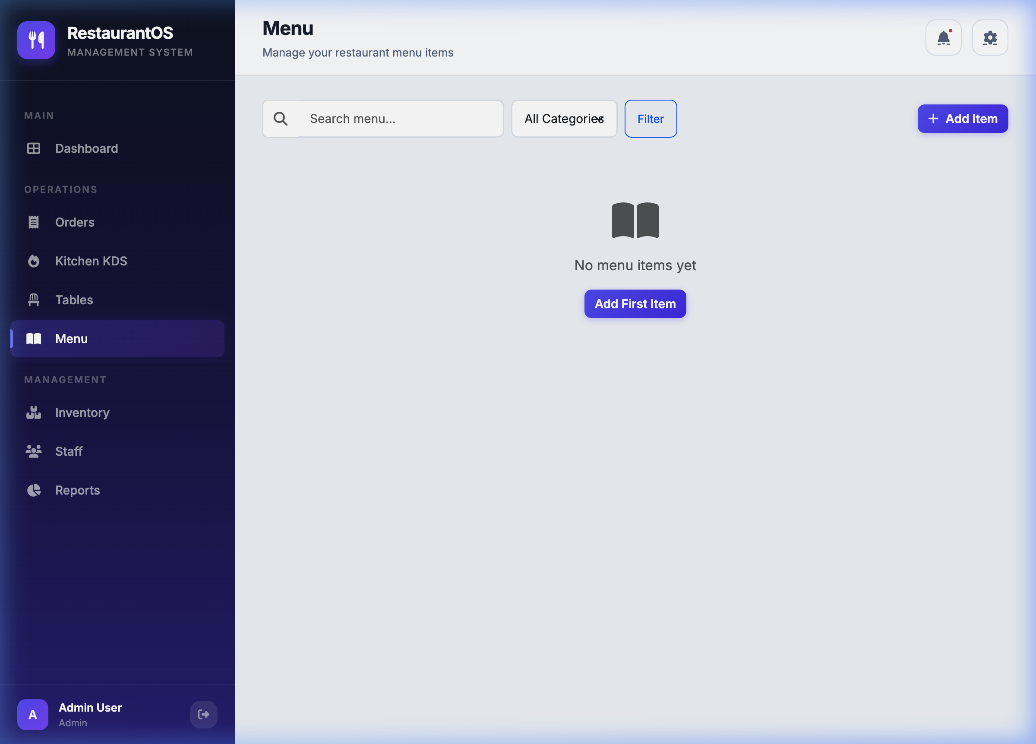
Figure A.15: Menu panel

Inventory Panel
Route: /inventory
Role: Manager/Chef
The inventory panel tracks stock levels, ingredient usage, and low-stock operational alerts.
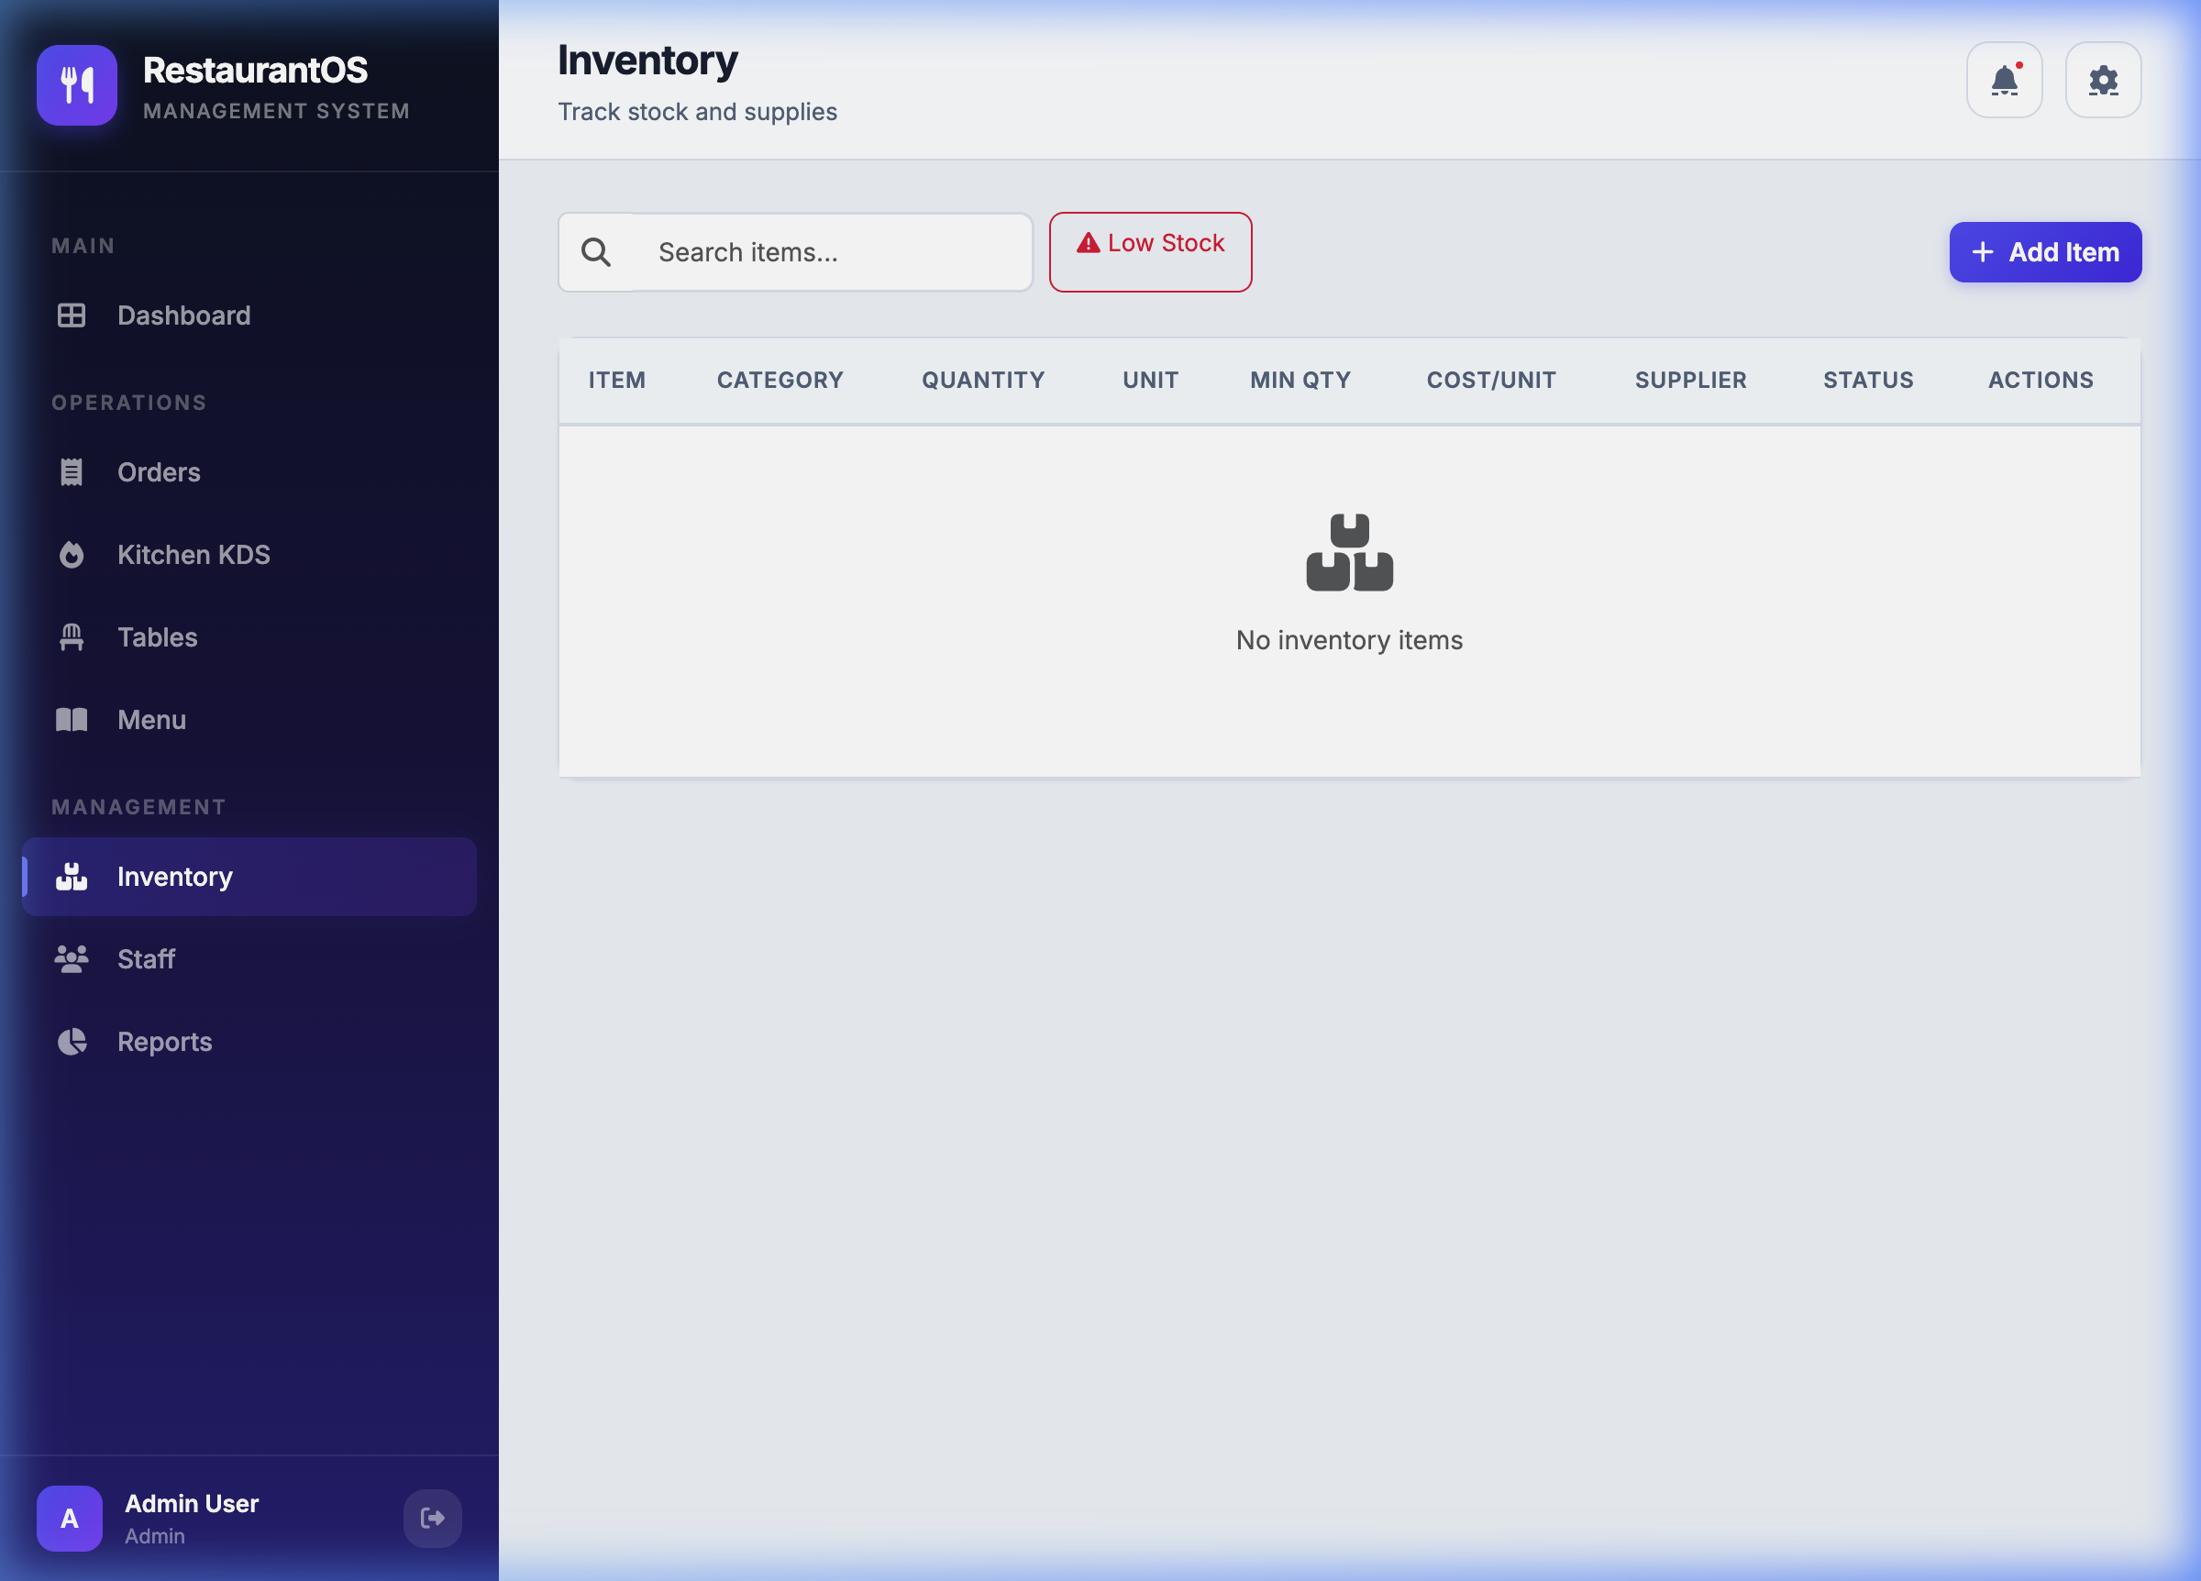
Figure A.16: Inventory panel

Staff Panel
Route: /staff
Role: Manager
Managers can manage employee accounts and assign staff roles.
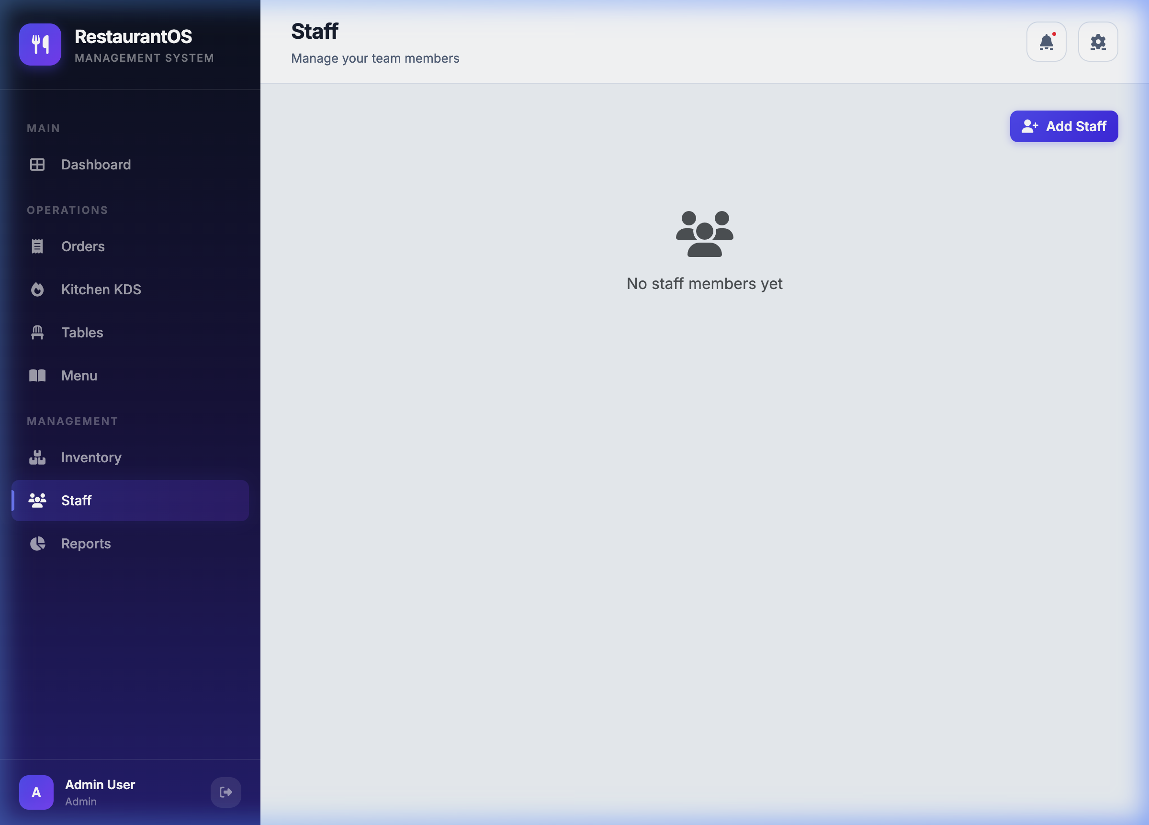
Figure A.17: Staff panel

Reports Panel
Route: /reports
Role: Manager
The reports panel presents sales analytics, revenue summaries, and performance information for management review.
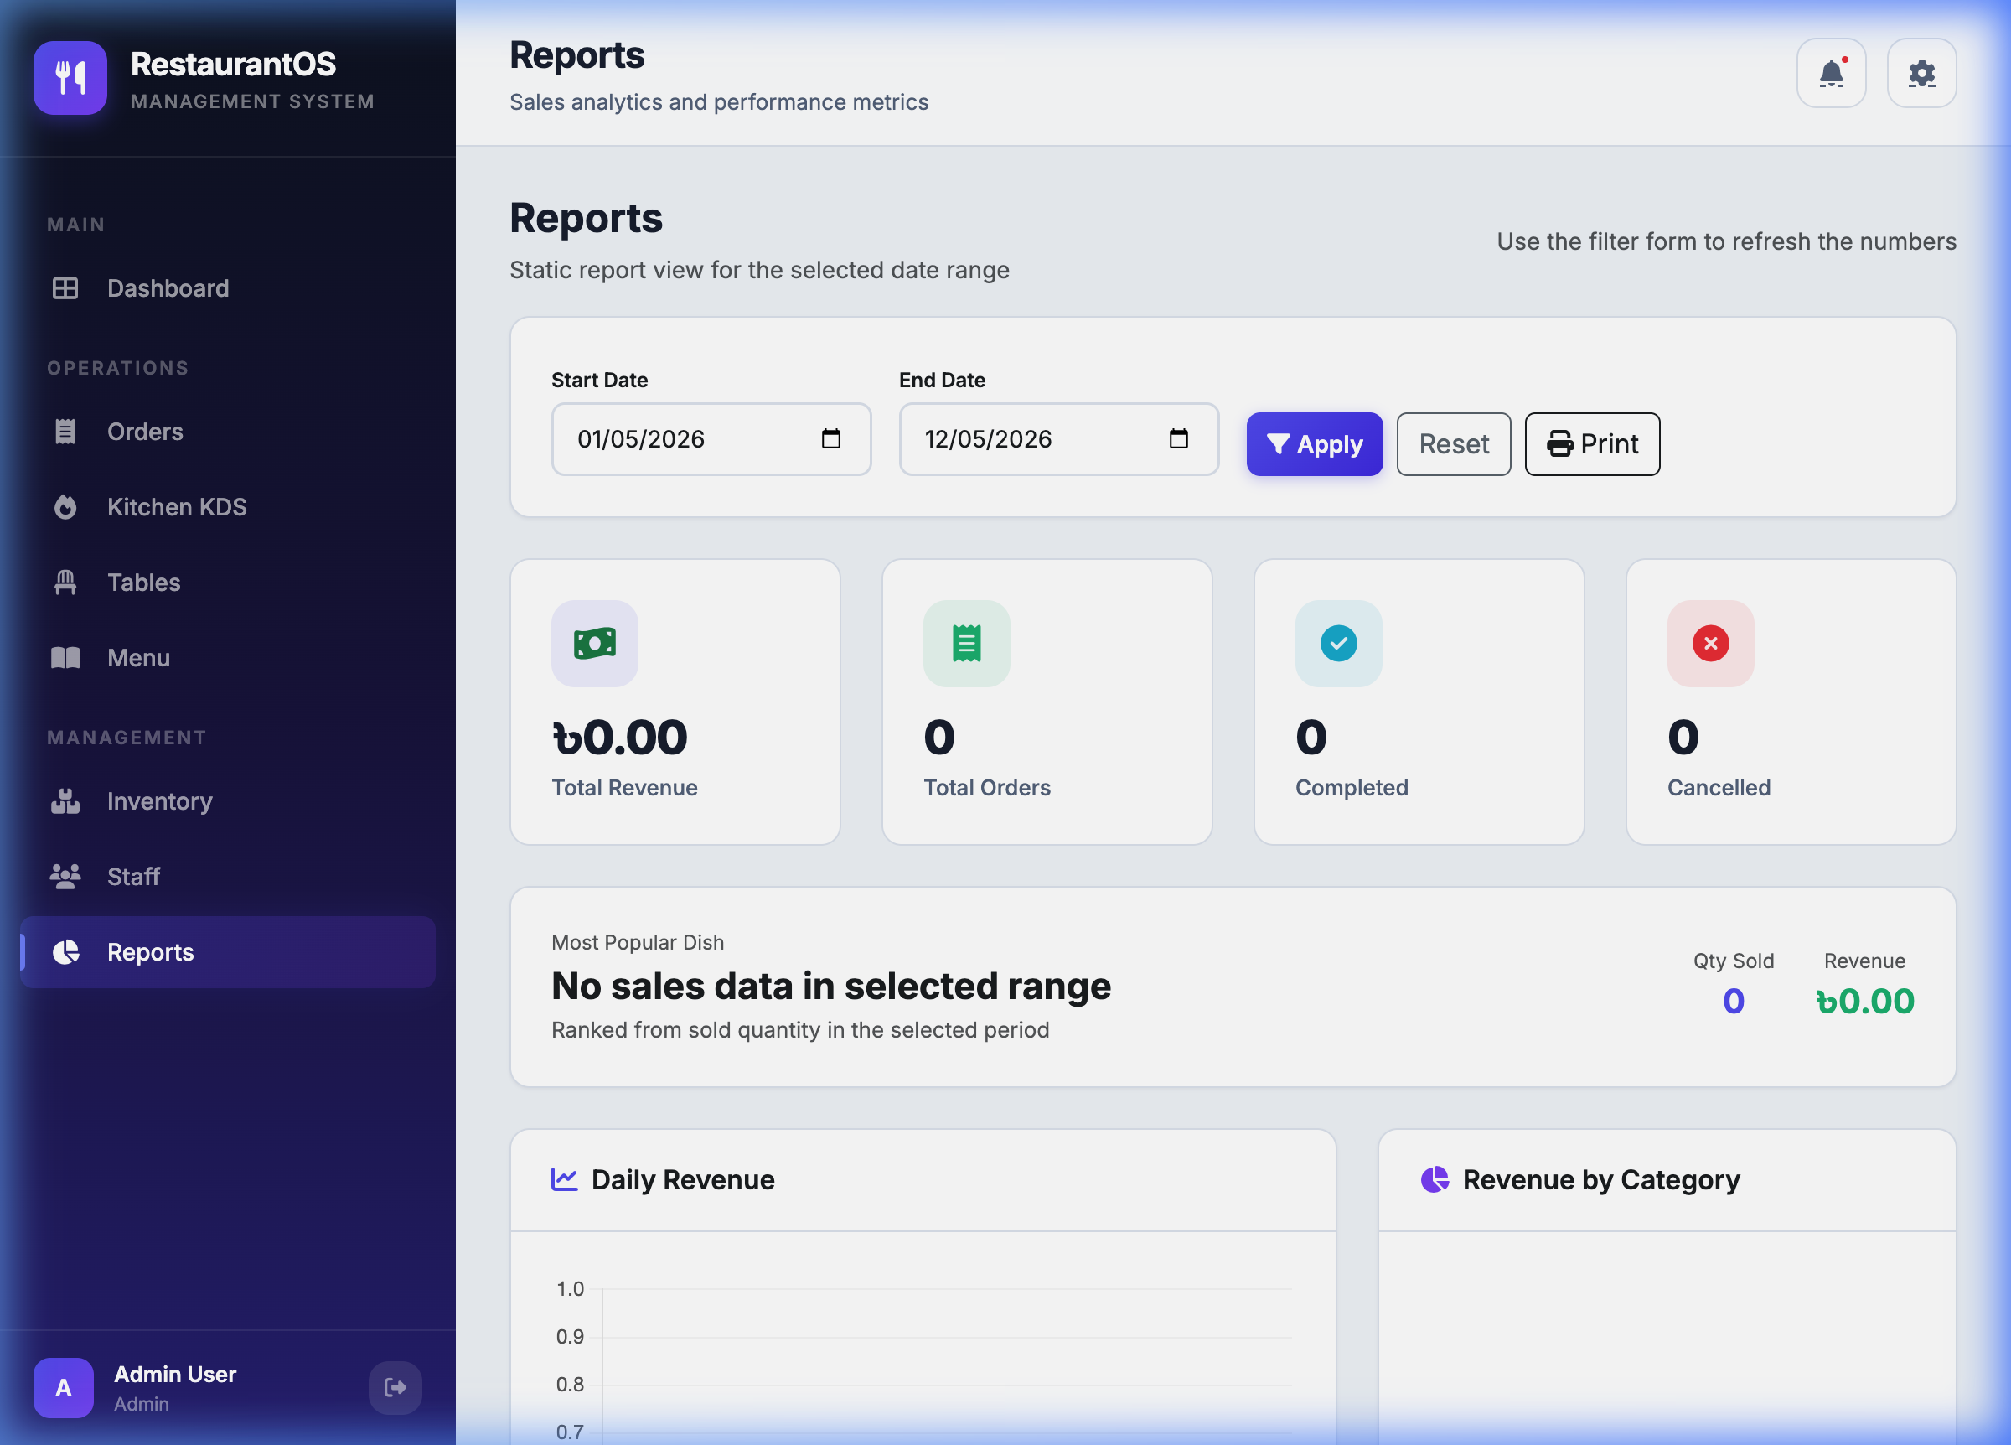
Figure A.18: Reports panel

Settings Panel
Route: /settings
Role: Manager
Managers can configure system settings and restaurant preferences from this panel.
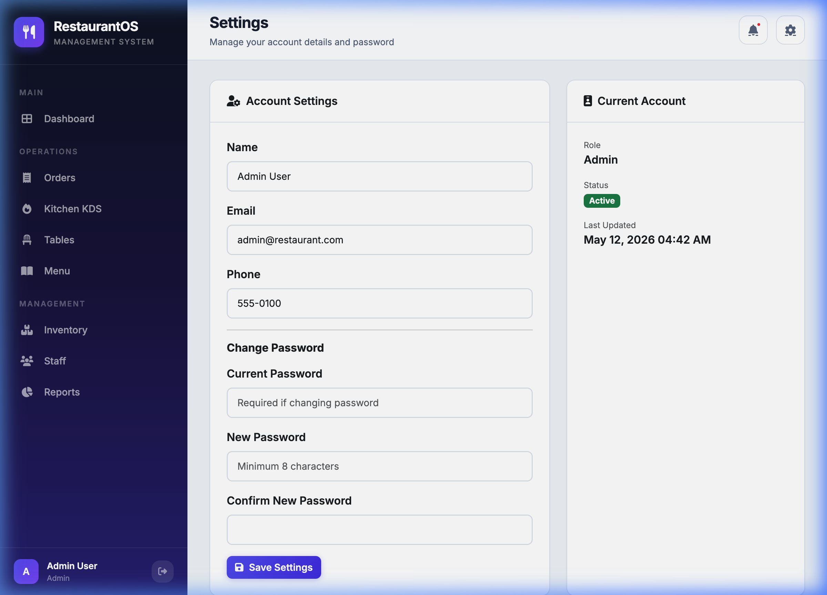
Figure A.19: Settings panel

Notifications Panel
Route: /notifications
Role: All Staff
Staff can review system alerts, order updates, and operational notifications.
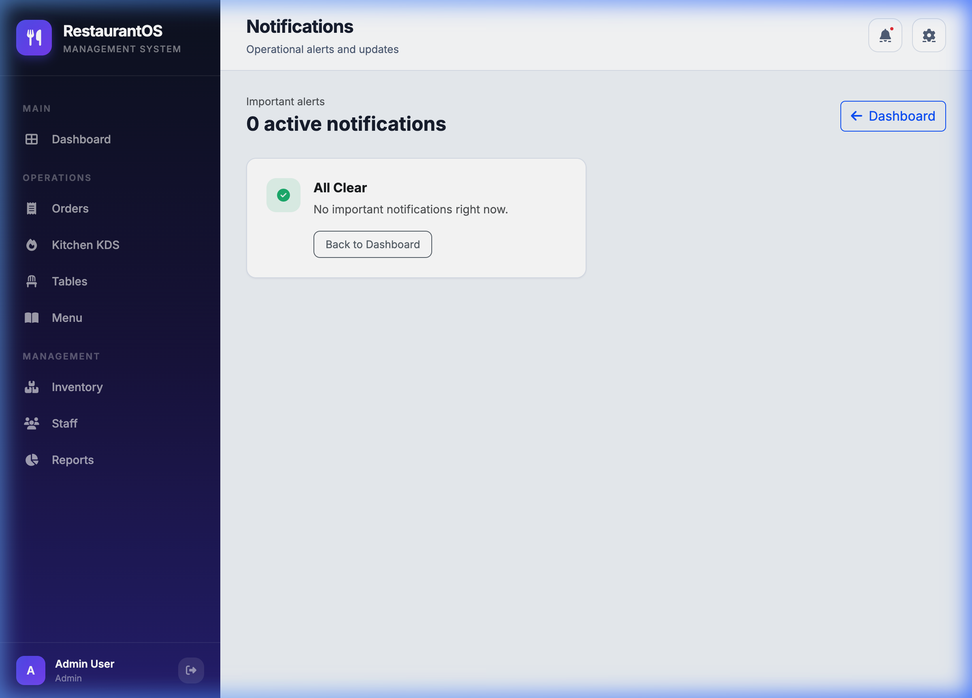
Figure A.20: Notifications panel

Visual Walkthrough Summary
Table A.1: Visual Walkthrough Summary
# | Page / Panel | Route | Role
1 | Landing Page: Hero Section | / | Public
2 | Landing Page: Menu Showcase | / | Public
3 | Landing Page: About and Features Section | / | Public
4 | Landing Page: Gallery Section | / | Public
5 | Landing Page: Footer | / | Public
6 | Customer Login Page | /customer/login | Public
7 | Customer Registration Page | /customer/register | Public
8 | Customer Account Page | /customer/account | Customer
9 | Customer Orders and Menu Page | /customer/orders | Customer
10 | Staff/Admin Login Page | /login | Public
11 | Dashboard | /dashboard | Manager
12 | Orders Panel | /orders | Manager/Cashier
13 | Kitchen KDS Panel | /kitchen | Chef
14 | Tables Panel | /tables | Manager
15 | Menu Panel | /menu | Manager/Chef
16 | Inventory Panel | /inventory | Manager/Chef
17 | Staff Panel | /staff | Manager
18 | Reports Panel | /reports | Manager
19 | Settings Panel | /settings | Manager
20 | Notifications Panel | /notifications | All Staff
The screenshots confirm that the RMS includes a complete public customer journey, separate customer authentication, staff/admin authentication, and operational panels for dashboard monitoring, orders, kitchen workflow, tables, menu, inventory, staff, reports, settings, and notifications.

References
- [1] Sommerville, I. (2015). Software Engineering (10th Edition). Pearson Education.
- [2] Albrecht, A. J. (1979). Measuring Application Development Productivity. Proceedings of IBM Applications Development Symposium.
- [3] Garmus, D., & Herron, D. (2001). Function Point Analysis: Measurement Practices for Successful Software Projects. Addison-Wesley.
- [4] Laravel Framework Documentation. (2024). https://laravel.com/docs/11.x
- [5] MySQL 8.0 Reference Manual. (2024). https://dev.mysql.com/doc/refman/8.0/en/
- [6] Bootstrap 5 Documentation. (2024). https://getbootstrap.com/docs/5.0/
- [7] SSLCommerz Payment Gateway Documentation. (2024). https://sslcommerz.com/docs/
- [8] OWASP Top 10 - 2021 Web Application Security Risks. https://owasp.org/Top10/
- [9] Pressman, R. S., & Maxim, B. R. (2014). Software Engineering: A Practitioner's Approach (8th ed.). McGraw-Hill.
- [10] IEEE Standard for Information and Communication Technology - Software and Systems Engineering. (2017).

